From “Toilet Revolution” to Smart Urban Governance:
Citizen Perceptions of Eco-Friendly Public Toilets in Shijiazhuang, China

Introduction:

In 2018, “Chinese cities began to implement a nationwide initiative called the ‘toilet revolution’”, which is part of efforts to “improve basic sanitation facilities and meet the goals of ecological civilization and smart cities”. In Shijiazhuang, Hebei Province, this upgrading of basic sanitation facilities has taken the form of renovating “Shijiazhuang renovated 244 public toilets as part of the city’s implementation of the nationwide Toilet Revolution initiative, according to the concept of “one toilet, one scene”, and emphasizing differentiated facility levels and modern design concept”. The newly renovated “five-star” toilets “feature larger spaces, gender-friendly spaces, mother-and-baby rooms, accessible spaces, and rest areas that combine hygiene, comfort, and beauty”. The newly renovated toilets also feature innovative deodorization technologies that include “plant misting” and “negative pressure air circulation”, as well as smart management technologies that can simulate toilet location and usage real time to create a smart public space.
However, less attention has been devoted in understanding how these upgrades affect people's experiences. The research paper investigates how urban residents perceive these technologies and design innovations, which on the other hand can reveal how urban residents understand these upgrading efforts and how it reflects the changing relationship between the state and society. The research, based on a case study of Shijiazhuang, Hebei Province, addresses the following questions: (1) how do urban residents rate the comfort, inclusiveness, and security of newly renovated toilets? (2) how do smart management and environmental technologies affect urban residents' perceptions of government responsiveness? (3) how do gender, age, and mobility affect urban residents' access to and use of “smart” sanitation facilities?.

Literature Review:

Research into China’s “Toilet Revolution” reveals the change from a sanitation project to an urban governance idea. Research carried out by Darya (Iossifova, 2020) reveals the sanitation campaign as both social and technical development. The “toilet revolution” reveals how infrastructure is able to integrate the three major perspectives of environmental health. Also the political sector of modernization instead of toilets has been seen as simple to implement. In conclusion, Darya reveals the construction within the wider perspective of transformation in the urban landscape.
Research by Yue (Allen, 2022) reveals an unique perspective of seeing public toilets as a form of public service. He explained how the government utilizes the sanitation campaign to demonstrate their administrative ability. This reveals how the improvement of toilets can be seen as the care of the public under the face of rapidly expanding urbanization. “Rural access to sanitary toilets increased from 7.5% in 1993 to 68% by the end of 2020”.

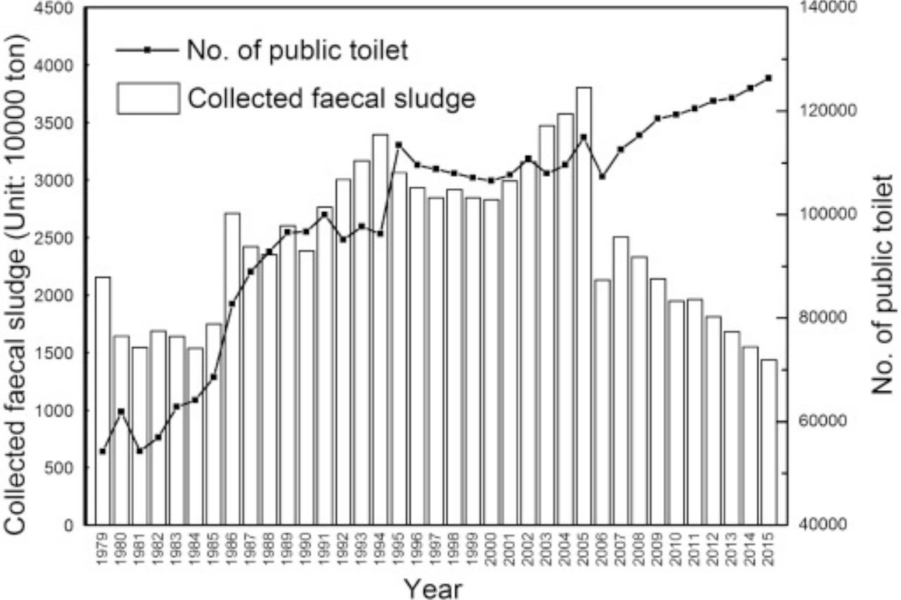
Outside the perspective of China, user-based research reveals further insight into the improvement of toilets. Research carried out by Fernanda D. (Moreira et al, 2022) into the perspective of the citizen’s experience of the public toilet in Brazil reveals how the feedback from the cleanliness, safety, and accessibility of the toilet can highly demonstrate the satisfaction of the user with the public facilities. Similarly, research carried out by K. V. (Horadi, 2024) reveals how IoT monitoring systems can be used to prove the efficiency of the infrastructure and the optimization of the maintenance; however, it fails to take into account the social sector.
Although the research provides an important perspective into the improvement of toilets, there are three blanks remaining. The majority of the research carried out is either on the rural sector or innovation; however, the citizen in the urban landscape is still underestimated. Furthermore, the research fails to take into account the integration of technology, digital government, and dignity within the framework of analysis. In addition, inequalities of age and gender are mentioned but not explored within the smart sanitation.
This research aims to fill the gaps between the infrastructure and the citizen’s perspective of the improvement of toilets. This research contributes to the debate on digital government and the role it plays in the construction of the perspective of the citizen’s dignity.

Research Methods:

This research used mixed research methods: including surveys, case studies, and secondary research. The research begins with a structured survey that targets users of various classification levels and urban districts of improved public toilets in Shijiazhuang. “To assess residents’ perceptions of eco‑friendly and smart toilets, this study parallels previous large‑scale surveys of toilet infrastructure under China’s Toilet Revolution. For example, a multi‑province investigation collected 1,203 valid responses from both online and offline questionnaires, measuring factors such as facility conditions, humanized services, and sanitation satisfaction across urban and rural settings. Such data provide a benchmark for public perception analysis and help contextualize survey findings on comfort and inclusiveness.”
The researchers then carry out semi-structured interviews with municipal officials from the public toilet and smart toilet industry. Finally, the research incorporates secondary research by using anonymous smart toilet management platform data. “A public toilets cloud platform displays real time data for more than 270,000 public toilets across 346 Chinese cities since 2017”. Using these research methods, we can compare users’ experiences, which gives us insight into users’ perceptions and actual performance.

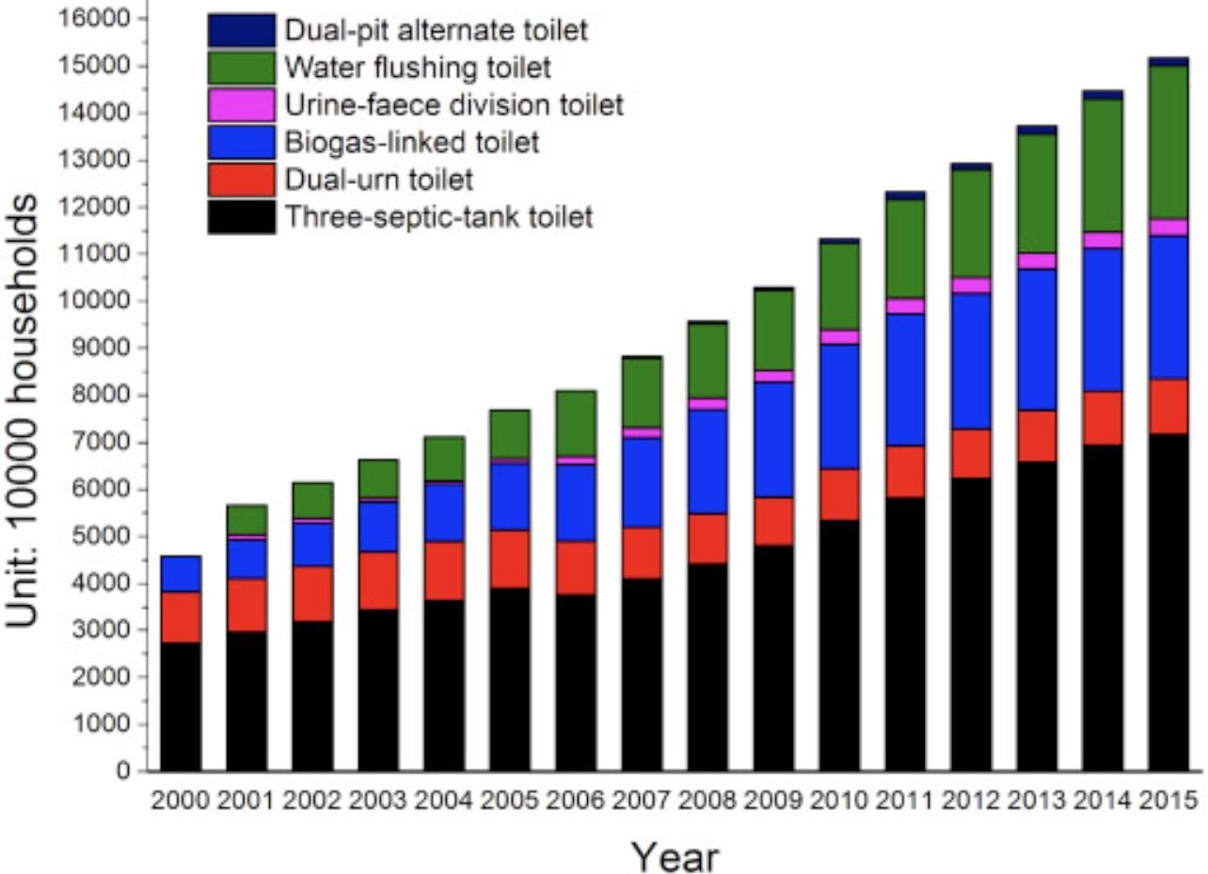

Research Findings:

The study demonstrates that toilets with advanced technology not only serve the function of keeping things clean, but also transform daily lives. Citizens can express their satisfaction with the cleanliness, ventilation, and odor control systems. Many of them state that the use of plant-based deodorizers and ventilation systems helps remove the bad smell associated with public toilets. The availability of separate sections for mothers and their children often rank as the most comfortable features, particularly for women and the elderly.
Meanwhile, the smart management features increase efficiency and transparency. Individuals interpret the use of real-time screens displaying the air quality, cleaning time, and number of people as indicators that the government is accountable and responsible. In addition, the use of mobile apps indicating the direction and number of people in the toilet helps the public feel that the local government cares about their lives and takes their views seriously.
However, challenges still exist. Elderly people often lack the ability to use mobile apps and rely on traditional signs. Individuals also express that the “five-star” toilets, ranked as the highest standard, are concentrated in the central districts, while the peripheral districts remain behind. Women express their concerns that even though the toilets have advanced technology, during peak hours, the waiting time remains long.
According to the maintenance data from the online operations platform, the overall performance remains steady. Sometimes the system may face some technical issues, such as the screens are not functioning right. Individuals express their dissatisfaction and doubt about smart technology.
Overall, the study demonstrates that eco-friendly and smart toilets serve two functions. Not only the improvement of the cleanliness and sanitation of the toilets, but they also symbolize the modernity and advancement of the city and the government. However, the credibility and trust created through smart toilets rely on fair and efficient maintenance.

Conclusion & Limitations:

This research demonstrates that smart and eco-friendly public toilets in Shijiazhuang are more than just simple upgrades over public facilities. They are spaces where dignity, citizenship, and governance are enforced. The research contributes to many existing research and studies on urban infrastructure and digital governance by focusing on user experience and how social inequalities are expressed.
However, this research has some limitations. This research only focuses on a single city, which makes it narrow and difficult to generalize to other cities that have different financial or environmental backgrounds. On the other hand, the research used survey methods, which only measure immediate reactions to smart toilets rather than long-term effects in behavior. Future research could build on this by comparing multiple cities and measuring long term shifts over time to further understand how smart toilets reshape citizenship in the city as it continues to develop.

References:

Allen, Y. (2022). China’s toilet revolution as public goods provision: Local governance of public toilets in peri-urban Shanghai. India China Institute. https://www.indiachinainstitute.org/wp-content/uploads/2022/04/Allen-Chinas-Toilet-Revolution-as-Public-Goods-Provision.pdf
Gao, Y., Tan, L., Zhang, C., Li, Q., Wei, X., Yang, B., Chen, P., Zheng, X., & Xu, Y. (2022). Assessment of environmental and social effects of rural toilet retrofitting on a regional scale in China. Frontiers in Environmental Science, 10. https://doi.org/10.3389/fenvs.2022.812727
Horadi, K. V., Mahima, S., & Shobhitha, H. L. (2024). Smart public toilet management and monitoring system using IoT. International Journal of Advanced Research in Science, Communication and Technology, 4(1). https://ijarsct.co.in/Paper15346.pdf
Iossifova, D. (2020). Urban (sanitation) transformation in China: A toilet revolution and its socio-eco-technical entanglements. In M. Keith & A. A. De Souza Santos (Eds.), Urban transformations and public health in the emergent city (pp. 102–122). Manchester University Press. https://pure.manchester.ac.uk/ws/portalfiles/portal/175496253/_9781526150943_Urban_transformations_and_public_health_in_the_emergent_city_Urban_sanitation_transformation_in_China.pdf
Li, Y., et al. (2024). What makes residents participate in the rural toilet revolution? Environmental Science & Ecotechnology, 19, 100343. https://pmc.ncbi.nlm.nih.gov/articles/PMC10755533/
Mahalsekar, N. P., Poojary, R. R., Ganapaiah, S., Sushmitha, S., & Sathisha, S. (2022). Intelligent hygiene monitoring system for public toilets. International Journal of Engineering Research & Technology, 11(6). https://www.ijert.org/intelligent-hygiene-monitoring-system-for-public-toilets
Mao, L., Peng, M., Tian, Z., Liu, B., & Zhang, Y. (2024). Development of an index system for public toilets based on HRWS-PS theory and improvement strategies. Buildings, 14(11), 3424. https://doi.org/10.3390/buildings14113424
Moreira, F. D., Rezende, S., & Passos, F. (2022). Public toilets from the perspective of users: A case study in a public place in Brazil. Journal of Water and Health, 20(1), 41–53. https://iwaponline.com/jwh/article/20/1/41/85846/Public-toilets-from-the-perspective-of-users-a
Wang, H., Ma, X., & Zhang, K. (2024). The toilet revolution empowers rural revitalization based on a health perspective. Frontiers in Sustainable Development. https://doi.org/10.54691/ghx7e916
World Bank. (2021). China should focus beyond access to toilets to tap into the full potential of its rural toilet revolution. https://doi.org/10.1016/j.resconrec.2021.106100
UNICEF. (2018). Toilet revolution in rural China: Factsheet. https://www.unicef.org/china/en/reports/toilet-revolution-rural-china-factsheet
Cheng, S., Li, Z., Uddin, S. M. N., Mang, H. P., Zhou, X., Zhang, J., Zheng, L., & Zhang, L. (2018). Toilet revolution in China. Journal of Environmental Management, 216, 347–356.
National Bureau of Statistics of China. (2022). Statistical data on sanitary toilets (summary of rural household sanitary toilet coverage).
World Toilet Day: The ’Toilet Revolution’ in China. (2019). National Health Commission of China. Chinese public health reporting on rural and household toilets.
Xi leads China’s ’toilet revolution’. (2021). People’s Daily Online — reports on national public toilet numbers (370,000 by 2021).
People’s Daily Online. (2021, November 21). Xi leads China’s ‘toilet revolution’. People’s Daily Overseas Edition. https://en.people.cn/n3/2021/1121/c90000-9922263.html
China Daily. (2023, September 5). A toilet revolution has occurred in the nation and improved lives. https://www.chinadaily.com.cn/a/202309/05/WS64f68ecda310d2dce4bb3f45.html
The State Council of the People’s Republic of China. (2017, May 27). Toilet Revolution Progress Report. China Government Official Website. https://www.gov.cn/xinwen/2017-05/27/content_5197374.htm
LU, H., QI, Y., ZHU, M., & WEI, B. (2023). Investigation and discussion on the progress of urban and rural “Toilet Revolution” in various provinces. Environmental Sanitation Engineering, 31(3), 9‑14.
People’s Daily Online. (2021, January 7). China’s ‘toilet revolution’ brings new look to rural areas. https://en.people.cn/n3/2021/0107/c90000-9806803.html

