UNIVERSITY OF BUCHAREST
FACULTY OF SOCIOLOGY AND SOCIAL ASSISTANCE
DOCTORAL SCHOOL OF SOCIOLOGY

Policies, Trends, and Practices: Insights into Reproductive Rights in Post-Socialist Romania

BUCHAREST 2025

TABLE OF CONTENT

I. Introduction 4
II. Objectives 5
III. Limits 5
IV. Research methodology 5
V. Literature review 6
VI. Results 9
6.1. Legislative framework 9
6.2. Data analysis 12
6.3. Analysis of the World Value Survey Database on Abortion, Religiosity, and Gender Equality in a Democratic State 14
6.4. Statistical correlations 15
VII. Conclusions 16
ANNEXES 18
Annex 1: Number of reported abortions committed between 1967 - 1989 18
Annex 2: Number of reported abortions in state hospitals after 1990 19
Annex 3: Institutions that do not perform abortions on request 20
Annex 4: Sex and age of the respondents 21
Annex 5: Important in life: Religion 23
Annex 6: Religious person 23
Annex 7: Confidence: Churches 23
Annex 8: Justifiable: Abortion 23
Annex 9: Men make better political leaders than women do 24
Annex 10: Men make better business executives than women do 24
Annex 11: Relationship between the sex of the respondents and religion 24
Annex 12: Relationship between the sex of the respondents and the degree of religiosity 24
Annex 13: Relationship between the sex of the respondents and the degree of confidence in churches 24
Annex 14: Relationship between the sex of the respondents and the degree to which abortion is perceived as justified 25
Annex 15: Relationship between sex and men and women in business positions 25
Annex 16: Relationship between sex and men and women in political positions 25
Annex 17: Bivariate Analysis 25
BIBLIOGRAPHY 26

Abstract
This paper examines attitudes toward women's reproductive rights in post-socialist Romania. The analysis is grounded in a gender sociology perspective, drawing on Gail Kligman’s (2000) account of reproductive politics under the socialist regime and its enduring effects in the post-socialist context. Complementarily, the study employs C. Wright Mills’ (1959) concept of the sociological imagination to illustrate how private, micro-level experiences are shaped by macro-level political and institutional decisions. Methodologically, the research engages with the Romanian legal framework on reproductive rights, explores crisis pregnancy initiatives, and conducts a descriptive and inferential analysis of secondary data on abortion. It further considers the conservative stance of the Romanian Orthodox Church and its relationship with the state. The conclusion highlights how the intersection of state policies and religious conservatism narrows women’s capacity to exercise their reproductive rights, shaping both bodily autonomy and the broader collective mentality surrounding reproductive freedom.
Keywords: the right to abortion; reproductive and sexual rights; the Orthodox Christian Church; traditional family.

I. Introduction
Romania is a state where the right to abortion has been, and continues to be, a highly contested issue, sparking extensive debates both at the institutional level and within one of the primary agents of socialization: the Romanian Orthodox Church. During the regime of Nicolae Ceaușescu, Decree 770/1966 imposed severe restrictions on women's ability to exercise this right, while Decree 771/1966 criminalized not only the women who sought abortions but also those who assisted them in the process (Official Bulletin, 1966). Furthermore, access to contraceptive methods was nearly non-existent. Currently, abortion has been legalized in Romania since 1989, but it is crucial to assess whether this right is merely enshrined in law (de jure) and not fully reflected in practice (de facto). Thus, we will investigate whether what is legislated on paper is effectively translated into reality. During the period of democratic transition, Romanian legislation frequently attempted to restrict women's right to abortion, while the Romanian Orthodox Church consistently supported these measures, condemning both abortion and other forms of contraception.
Regarding the temporal and spatial framework of this analysis, I will primarily focus on the legislation, events, and data relevant to the period between 1989 to the present. However, I will briefly review the legislation and some key data from the period 1966-1989, as the effects of Decree 770/1966 cannot be overlooked when discussing the issue of abortion in Romania. The data will be predominantly analyzed descriptively, though I will also draw some inferences, using abortion as the dependent variable.

II. Objectives
The main objective of this paper is to explore attitudes toward the right to abortion through a sociological lens. The secondary objectives are to critically examine the relationship between the Romanian state and the Romanian Orthodox Church regarding abortion from 1989 to the present, to analyze the Church’s stance on abortion, and to investigate how both institutions restrict women's exercise of this right in order to preserve the traditional family, as well as other sexual rights more broadly.

III. Limits
As a limitation of this study, I would like to mention that data regarding abortion in Romania is quite limited, so I will not be able to find data for every year included in the analysis.

IV. Research methodology
The research questions follwos the lines of the research objectives:

What is the legislative framework surrounding abortion in Romania after 1989?

How does the Romanian Orthodox Church position itself on the issue of abortion?

What is the stance of political decision-makers on abortion?

What is the current state of reproductive rights in Romania?

What societal attitudes toward abortion can be identified among the Romanian population?

What is the significance of the right to abortion in a democratic state?
In order to answer the questions above, I will look at some statistical and secondary data on abortion from institutions like the European Institute for Gender Equality, Eurostat, the Romanian National Institute of Statistics, the FILIA Center, and World Values Survey databases, spanning from 1989 to the present. A focused quantitative approach will be employed, using both descriptive and inferential analyses of the data, to derive insights and conclusions about trends, underlying factors, and policies shaping abortion practices and reproductive rights.

V. Literature review
In this section, I will examine the right of abortion from a Sociological perspective, with a particular focus on Gail Kligman’s insights in The Politics of Duplicity (2000). I will highlight the ways in which abortion was regulated during Nicolae Ceaușescu’s regime. Additionally, I will incorporate Charles Wright Mills’ (1959) concept of sociological imagination, emphasizing how private, micro-level issues are deeply influenced by macro-level social decisions. Before proceeding, it is essential to clarify the concept of the womanly, as this clarification will provide insights on how attitudes toward abortion are perpetuated within the socialization process. The term refers to experiences that are uniquely shared by women—such as menstruation, pregnancy, abortion, childbirth, postpartum recovery, breastfeeding, and menopause—experiences that stem primarily from women’s biological capacity for reproduction (Miroiu, 2004, p. 44). This concepts contrasts with the term feminine – which makes reference to those actions, activities and behaviours prescribed and expected from women only because they are women (such as doing their make up, acting sensitive, performing domestic chores within private sphere, raising children, or working as secretaries). The main problem here is related to the degree to which women have the right to perform abortion (as it is about their body and this should be related to their choices also), even though this highly contrasts the feminine norms (re)produced socially and culturally, which usually stands for traditional family (in which the role of women is to give birth and to be the primary caregivers). Given that reproductive rights are inherently womanly, it stands to reason that women should have primary authority over decisions concerning their own bodies. However, reproductive rights are often restricted by the conservative ideologies of both the state and the church, which are subsequently translated into policies that limit women’s autonomy over their own reproductive choices, and this is what I aim to approach below.
In The Politics of Duplicity, Gail Kligman (2000) provides an in-depth analysis of the pro-natalist policies enforced during Nicolae Ceaușescu’s regime. She argues that understanding reproductive policies is essential to comprehending the extent to which the state can abusively intervene in citizens' lives, even encroaching upon their sexual privacy (Kligman, 2000, in Miroiu, 2004). Kligman highlights that, over the 23 years of the pro-natalist decree, women were subjected to mandatory gynecological examinations—particularly those working in female-dominated industries, who underwent group medical screenings as well as compulsory individual check-ups (Kligman, 2000, in Miroiu, 2004). The state's ideal of the “political reconstruction of the family,” which sought to align social relations with the political and economic structures of the socialist state, ultimately led to state interference in citizens’ intimate lives through the political manipulation of abortion and contraceptive practices. This interference manifested in punitive measures against those who performed illegal abortions, as well as in severe physical, psychological, and moral traumas, and even in the deaths of women (Kligman, 2000). During the enforcement of the decree, abortion was portrayed as an act of mass murder, an existential threat to the biological future of the nation, an impediment to women’s fulfillment of their supposed destiny, and a danger to the prosperity of the homeland (Kligman, 2000). To restrict abortion access, procedures could only be performed with the approval of the prosecution office, while doctors and midwives who conducted illegal abortions or failed to report women seeking terminations faced criminal prosecution and professional disqualification (Kligman, 2000). As evident from the overview above, motherhood and fatherhood were transformed from personal choices into political obligations, making it increasingly difficult to escape the grip of state patriarchy (Miroiu, 2004). This difficulty is reflected in the legislative and policy initiatives proposed by political decision-makers—overwhelmingly male—when addressing abortion rights. It is also worth noting that during the enforcement of Decree 770/1966, contraceptive methods were banned, forcing women to rely on traditional and often ineffective means of preventing pregnancy.
Why this kind of approach? I have chosen to engage with Kligman’s (2000) perspective because it underscores the devastating consequences that Decrees 770/1966 and 771/1966 had on women in particular and Romanian society in general. These repercussions remain so profound that, despite the fall of the communist regime in 1989, political decision-makers have yet to implement a solution that fully enables women to exercise their right to abortion. Moreover, as will be demonstrated in the analysis of contemporary reproductive rights, political actors have not taken any substantial measures to facilitate women’s access to contraception or comprehensive sex education. On the contrary, as will become evident in discussions regarding the so-called pregnancy crisis initiative, male-dominated political leadership has attempted to significantly curtail women's abortion rights. In addition to these political shortcomings, the Romanian Orthodox Church continues to oppose abortion and other contraceptive measures, aligning itself with organizations that advocate for the so-called “traditional family.”
Another crucial Sociological perspective on how institutional decisions impact individuals' private lives is provided by Charles Wright Mills (1959) through his concept of sociological imagination. Mills (1959) argued that many personal troubles could be understood in terms of broader public issues (Thorpe et al., 2015). The core dilemma is that ordinary individuals often fail to make the connection between their private struggles and larger public policies, underscoring the need for experts to objectively evaluate societal challenges and inform decision-making accordingly (Thorpe et al., 2015). From Mills’ (1959) theory of sociological imagination, we can infer that the challenges faced by individuals are not solely personal burdens but also societal issues, in which power is concentrated in the hands of political elites (Nagle, 2016). In the case of abortion, what I can say in relation to this theory is the fact that we are witnessing a form of gender inequality that restricts women's access to a medical procedure—an inequality that is a direct product of societal structures. Political decision-makers (the elite) actively oppress women through restrictive policies. Furthermore, beyond legislative restrictions, societal attitudes toward abortion—whether conscious or unconscious—are shaped by the cultural and institutional environment in which people are socialized. These attitudes are reinforced by restrictive laws and by the way in which women's roles and gender relations are framed.
This enduring struggle to break away from the traditionalist legacy of the communist regime is further highlighted by Janet Johnson and Jean Robinson in Living with Gender and Contradiction (2003), a work that examines the multifaceted challenges faced by women, including the control over reproductive rights and abortion access. The authors argue that the post-communist political landscape remains dominated by neo-traditionalist influences, which—alongside the offensive objectification of women as sex symbols—also promote a return to the idealization of motherhood (Johnson & Robinson, 2003, p. 1, in Miroiu, 2004). They further contend that neo-traditionalist ideologies in post-communist states systematically ignore women’s issues (Johnson & Robinson, 2003, p. 1, in Miroiu, 2004), thereby further eroding women’s autonomy over their own bodies.
Thus, my decision to adopt these Sociological perspectives are grounded in their ability to illuminate the systemic challenges faced by women in transitional states, particularly in relation to abortion rights and the societal glorification of motherhood. Moving forward, I will outline the legislative framework governing abortion in Romania. This will begin with a brief historical overview of abortion laws and statistical data from the period between 1966 and 1989, followed by an examination of the legal context, the pregnancy crisis initiative, and relevant data from 1989 to present. As mentioned in the introduction, while this study does not primarily focus on the status of abortion during Nicolae Ceaușescu’s regime, the profound and lasting impact of Decrees 770 and 771/1966 cannot be overlooked.

VI. Results

6.1. Legislative framework
The pronatalist policy established by Decree 770/1966 aimed to rapidly increase demographic growth. The decree stipulated that abortions were permitted only in cases where the mother’s life was at risk, if one of the parents suffered from a hereditary disease, if the pregnant woman had physical or mental disabilities, if she was over 45 years of age, if she had already given birth to and was raising four children, or if the pregnancy resulted from rape or incest (Decree 770, 1966). These restrictive conditions were compounded by the absence of contraceptive methods, a lack of sexual education, and the rigorous oversight exercised by state authorities over medical institutions and their personnel. Medical professionals risked prosecution (under Decree 771/1966) and/or dismissal if they failed to report cases of abortion or were found to have performed illegal procedures (Apostol & Iancu, 2012). The description above illustrates the severe restrictions placed on abortion, as well as Nicolae Ceaușescu’s profound commitment to increasing birth rates—an objective that clearly took precedence over Romanian women’s freedom of choice and their fundamental right to bodily autonomy.
Annex 1 presents the number of abortions performed between 1967 and 1989. During the period 1967–1970, the number of abortions exceeded 200,000 annually. Between 1971 and 1978, and again in 1984, this figure surpassed 300,000, while between 1971 and 1982 (with the exception of 1981), it consistently exceeded 400,000. Toward the end of the regime, a decline in recorded abortions is observed, with figures falling below 200,000. These statistics demonstrate that, despite the state’s control over women’s reproductive rights, abortions continued to be performed. However, they were conducted in secrecy, often through unsafe methods that resulted in severe complications and, in many cases, fatalities. The estimated number of women who lost their lives due to these restrictive policies exceeds 10,000, in addition to the countless others who endured profound physical and psychological trauma (Apostol & Iancu, 2012).
Following the fall of Ceaușescu’s regime, on December 27, 1989, Decree-Law 1, Article 8, legalized abortion on request within the first three months of pregnancy. Terminations beyond this period were permitted in cases of medical necessity or when the parents suffered from a hereditary condition (Apostol & Iancu, 2012). In 1996, Article 185 of the Penal Code was reintroduced, criminalizing abortions performed beyond 14 weeks of gestation, outside of medical institutions, or by unqualified individuals—though exceptions were made for therapeutic reasons (Penal Code - Art. 185, 1996). Notably, Romanian legislation makes no explicit reference to abortion access for minors, victims of rape, or survivors of other forms of sexual violence. A legislative proposal from the Ministry of Health sought to grant minors the right to abortion up to 24 weeks of pregnancy, but the proposal ultimately failed to pass in Parliament (Apostol & Iancu, 2012, p. 54). This initiative was a response to the widely publicized case of an 11-year-old rape victim who became pregnant. Since her pregnancy was discovered at 17 weeks—beyond the legal threshold for abortion in Romania—she was forced to seek the procedure in the United Kingdom, where abortion is permitted up to 24 weeks (Apostol & Iancu, 2012). As these examples illustrate, Romania’s legal framework remains profoundly inadequate and rigid when it comes to women's reproductive rights. Even in exceptional circumstances, victims encounter numerous institutional hurdles that, rather than supporting them, further complicate their plight. Potential solutions that could alleviate these challenges are disregarded, leaving victims in distress and preventing meaningful improvements in institutional attitudes, policies, and procedures related to abortion and broader women's health issues.
In 2009, Article 201 of the new Penal Code, titled "Aggressions Against the Fetus," established a 24-week limit for medically justified abortions (Penal Code - Art. 201, 2009). Compared to previous legislation, which allowed abortions beyond 14 weeks in certain cases, Article 201 rigidly restricted the right to abortion after 24 weeks without exceptions. However, under pressure from civil society, the final version of Article 201 included paragraph 6, which permitted terminations beyond 24 weeks "for therapeutic purposes, in the interest of the mother or the fetus" (Penal Code - Art. 201, 2009). The evolution of this legal provision underscores the persistent indifference of political decision-makers toward women's rights—a stance that not only undermines women's ability to exercise their reproductive rights in a democratic state but also endangers their lives by forcing them to seek unsafe abortion methods when institutional support is denied.
In this regard, I would also like to discuss the proposed legislation on "pregnancy crisis counseling," a bill that, beyond questioning women's decision-making and rational capacity, was clearly designed to discourage them from seeking abortions. In 2012, Members of Parliament Marius Dugulescu and Sulfina Barbu, both representatives of the Democratic Liberal Party, introduced a draft law on "the establishment, operation, and organization of pregnancy crisis counseling offices" (Dugulescu & Barbu, 2012). This proposal promoted the notion of an "inherent right to life" for the unborn child and would have applied to all women considering abortion. I have chosen to discuss this bill because it exemplifies the close relationship between the Romanian state and the Orthodox Church. The proposal received support not only from a significant number of male-dominated Democratic Liberal Party parliamentarians but also from religious NGOs, including the Federation of Orthodox Pro-Life Organizations, the Pro-Vita Clinical Foundation, the Pro-Vita International Clinical Association, and the Arsenie Boca Foundation (Apostol & Iancu, 2012, p. 55). The bill severely infringed upon women's right to privacy, as it required them to provide detailed justifications for their decision to terminate a pregnancy in front of a counselor. Moreover, it violated their right to refuse unwanted information, as women considering an abortion would have been subjected to audio-visual materials graphically depicting the abortion procedure. Their bodily autonomy was further compromised by mandatory ultrasound scans of the embryo or fetus and the imposition of alternative solutions, such as adoption or foster care placement (Apostol & Iancu, 2012). The issuance of a "counseling certificate," which required women to sign a declaration acknowledging that "the fetus is a living human being from the moment of conception" (Apostol & Iancu, 2012), was particularly problematic. As the arguments above illustrate, beyond restricting the right to abortion itself, this bill treated the fetus as a fully entitled legal subject, disregarding the fact that, according to the European Convention on Human Rights, the right to life applies only to individuals with rational capacity, from birth until death (Art. 2, ECHR, 2008). Additionally, the bill’s proponents invoked so-called medical arguments—such as "post-abortion syndrome"—which lack scientific validation and are not recognized by any reputable international institution (Apostol & Iancu, 2012). Although the bill ultimately failed, it demonstrated how political decision-makers often resort to unscientific justifications to advance their agendas, within a state that pretends to share liberal and democratic values.
The problematic relationship between the state and religiously affiliated organizations remains evident, particularly considering the Orthodox Church’s staunch opposition to abortion and contraception. Instead, these groups actively promote traditional family values, childbearing, and rigid gender roles. Given that both the state and the Church share the common objective of increasing birth rates and restricting abortion access, the exercise of reproductive rights by Romanian women continues to be increasingly constrained. Having outlined the legislative framework, the following section will present a descriptive and inferential analysis of statistical data on abortion in Romania after 1989.

6.2. Data analysis
Annex 2 suggests that, following the fall of Nicolae Ceaușescu’s regime, there was an explosion in the number of abortions performed in state hospitals. In 1990, nearly one million abortions were recorded, and by 1996, this figure had declined to approximately half. In 1997, over 300,000 abortions were reported, while between 1998 and 2003, the number consistently remained below 300,000. From 2004 to 2011, this figure further decreased to under 200,000, with a sharp decline recorded between 2012 and 2017, when the number of abortions in public hospitals dropped dramatically below 100,000. These figures underscore the staggering number of abortions performed post-1989, illustrating how the legalization of abortion led to a nationwide surge in its prevalence. The significant correlation between these numbers and Romania’s ongoing demographic decline likely explains the legislative initiatives mentioned earlier, as well as the proposed pregnancy crisis bill, both of which sought to restrict women's access to this fundamental right.
However, policymakers fail to acknowledge the broader social, institutional, and—above all—economic deficiencies that hinder child-rearing in Romania. The reality remains that many families and couples opt for abortion due to financial constraints. Furthermore, despite low birth rates and a high number of abortions, the availability of childcare facilities—both public and private—remains inadequate. The situation is even more dire for single mothers, who receive little to no support from the state (Băluță, 2011). These are just a few of the critical aspects that decision-makers should prioritize, rather than attempting to curtail women’s reproductive rights.
Moreover, although abortion has been legalized, it remains a highly inaccessible right, as illustrated by the latest report from the Filia Center. As shown in Annex 3, the majority of public hospitals refuse to perform abortions on request, with an alarmingly high percentage also refraining from carrying out the procedure during religious holidays. This highlights the undue influence exerted by the Romanian Orthodox Church over medical institutions. Despite abortion being legally recognized in Romania, the data suggests that religious values often take precedence over the law. Even more concerning is the fact that numerous hospitals refuse to provide abortion services altogether, while the Romanian state remains indifferent to this blatant restriction of women’s rights.
In addition to institutional barriers, accessibility is further hampered by financial and bureaucratic constraints. Women living in counties where hospitals refuse to perform abortions must endure significant logistical and financial burdens to access these services elsewhere. Furthermore, the process itself is often hindered by excessive administrative red tape, while the cost of obtaining an abortion ranges between 100 and 650 RON (as of 2019) (Bragă, 2019), placing an additional burden on those in vulnerable financial situations.
I conclude this section by addressing one final issue: reproductive health and sexual rights. Beyond the abortion crisis, a 2018 report by the Filia Center reveals significant shortcomings in women’s reproductive healthcare and persistent restrictions on their sexual rights. Since 2016, Romania has been the only country where contraceptives are no longer available free of charge through family doctors, regardless of the patient’s circumstances. Alarmingly, 10% of all mothers giving birth each year are minors, 5 out of 10 teenage mothers have never visited a gynecologist, and 6 out of 10 have never had access to information on reproductive health. The average age at which Romanian adolescents begin their sexual lives is 15 and a half, while 3 out of 10 women aged 15–49 do not use any form of contraception (Bragă, 2018).
These statistics underscore the fact that contraceptives in Romania are only accessible to those who can afford them—an issue that disproportionately affects the most vulnerable, who are also at the highest risk of unwanted pregnancies. The prevalence of teenage motherhood reflects not only the deficiencies in sexual education but also the inaccessibility of reproductive health services and information. These are urgent issues that should be at the forefront of policymakers’ agendas. However, the Romanian Orthodox Church’s steadfast opposition to contraception and abortion remains a major obstacle, as evidenced by its active support for annual events such as the "March for Life."

6.3. Analysis of the World Value Survey Database on Abortion, Religiosity, and Gender Equality in a Democratic State
Next, I will conduct a brief descriptive and inferential analysis of data obtained from the World Value Survey database for Romania in 2017, which includes information relevant to the subject of this study. Below, the socio-demographic characteristics of the study participants, categorized by sex and age, are presented. As shown in the tables, the majority of respondents are women (52.2%), while men constitute 47.8% of the sample. The respondents' ages range from 18 to 85 years. In the analysis, I will emphasize the percentage distribution of each variable, excluding missing values. However, for transparency, I have included missing values in the annexes so that readers can assess their proportion in the analyzed data.
Annex 5 indicates that most Romanians consider religion to be very important (47.3%) or fairly important (30.8%), with only a small percentage stating that religion is not very or not at all important. Additionally, Annex 6 shows that 73.6% of respondents identify as religious. Furthermore, as seen in Annex 7, a significant proportion of respondants express high trust in the Church (39.7%), whereas only 8.5% report having no trust in this institution. Taken together, these findings suggest that Romanian society is predominantly religious and places considerable trust in religious institutions.
With regard to abortion, Annex 8 reveals that half of the respondents (50%) believe that abortion is never justifiable, while the remaining levels of opposition to this medical procedure remain relatively high. Only a small fraction (2.4%) consider abortion to be always justifiable. These results indicate a general reluctance among Romanians toward abortion.
Since the discussion also touches upon women's autonomy in making decisions about their own bodies, it is useful to examine respondents’ views on women in leadership positions, both in general and in politics specifically. Annex 9 shows that a majority of respondents disagree (31.1%) or strongly disagree (23.9%) with the idea that men make better political leaders than women. However, a notable proportion still agree to some extent (13.1%) or completely (24.1%) with this statement. Similar trends can be observed in Annex 10, which presents opinions on whether men are better decision-makers than women. Overall, the data suggest that most respondents do not perceive a significant gap in leadership competence between men and women in decision-making and political roles.
In the next section, I will conduct a series of statistical correlations relevant to the subject of this study, using data from the World Value Survey Wave 7 – Romania 2017.

6.4. Statistical correlations
From Annex 11, we can observe that when it comes to the relationship between gender and the importance of religion, women, to a greater extent than men, consider religion to be important in their lives. Annex 12 further reveals that women identify as religious at a higher rate than men. Additionally, Annex 13 shows that women tend to have slightly more trust in the Church compared to men.
In relation to abortion, there are no significant differences in the relationship between gender and the justification of abortion. A relatively equal proportion of both women and men believe that abortion is never justifiable (see Annex 14).
Regarding gender and women in leadership/political positions, we observe the following:
- The majority of respondents disagree with the assumption that men are better leaders than women. However, among those who agreed or strongly agreed, a larger proportion of men consider themselves more competent in leadership positions than women (see Annex 15).
- Similarly, when it comes to political leadership, the majority of respondents do not agree with the assumption that men are better political leaders than women. However, among those who expressed agreement or strong agreement, a slightly higher proportion of men consider themselves more competent in political positions than women (see Annex 16).
In Annex 17, we can observe a series of correlations between various variables using bivariate analysis. The purpose of this correlational analysis is to examine how the justification for abortion correlates with gender equality, age, and religious activism. The following results emerge from the analysis:
- A positive correlation (0.023), statistically significant (0.430), is observed between the democratic belief that women have the same rights as men and the justification of abortion. Therefore, as belief in gender equality increases, so does the tendency to consider abortion a justifiable medical procedure.
- A negative correlation (-0.062), moderately significant (0.034), is found between age and the justification of abortion. Thus, as age increases, the justification for abortion decreases.
- A negative correlation (-0.033), statistically significant, is observed between religious activism and the justification of abortion. As engagement in religious activities increases, the tendency to view abortion as justifiable decreases.
- A significant negative correlation (-0.175), statistically significant (0.000), is found between belief in the importance of God and the justification of abortion. Therefore, the stronger the belief in God's importance, the less people are likely to consider abortion a justifiable procedure.
From the above correlational analysis, we observe that the higher the level of religiosity and trust in religious institutions and figures, the less likely respondents are to consider abortion a justifiable procedure. This situation illustrates how deeply religiosity impacts collective mentality, a patriarchal mindset that undermines women's ability to exercise their reproductive rights.

VII. Conclusions
Instead of conclusions, I would say that although abortion has been legalized, political decision-makers continue to attempt to restrict the exercise of this right for women. The right to abortion, in particular, and sexual rights in general, are treated with indifference by the Romanian state’s decision-makers, revealing how a state in democratic transition minimizes the issues faced by women. Decision-makers seek to limit abortion in Romania as a response to the demographic decline the country is facing. Much like the Romanian Orthodox Church, the state opts to view women predominantly in the role of mothers, attempting to keep women confined to the domestic sphere. Furthermore, these patriarchal perspectives on women's reproductive rights influence collective mentality, steering it towards stereotypes and prejudices regarding abortion, which leads to the stigmatization and even discrimination of women exercising this right.
Overall, it is evident that Decrees 770 and 771/1966 have left a lasting imprint on the Romanian collective mentality, influencing the attitudes of political decision-makers to varying extents. What is particularly alarming is that these attitudes are reflected in actions at the macro level, which, as suggested by the concept of sociological imagination, predominantly affect the micro level, specifically women's rights in the private sphere.

ANNEXES

Annex 1: Number of reported abortions committed between 1967 - 1989
Year | Number of reported abortions
1967 | 206.000
1968 | 220.000
1969 | 258.000
1970 | 292.410
1971 | 330.000
1972 | 381.000
1973 | 376.000
1974 | 335.000
1975 | 359.417
1976 | 383.000
1977 | 379.000
1978 | 394.000
1979 | 404.000
1980 | 413.093
1981 | -
1982 |  | 468.041
1983 |  | -
1984 |  | 303.838
1985 |  | 183.959
1986 |  | 183.959
1987 |  | 182.442
1988 |  | 185.416
1989 |  | 193.084
TOTAL: | 6.549.823
Retrieved: Romanian National Institute of Statistics: http://statistici.insse.ro/shop/?page=tempo3&lang=en&ind=POP201G (accessed at 20.12.2023 (Abortions, 1967 - 1989);

Annex 2: Number of reported abortions in state hospitals after 1990
Year | Number of reported abortions
1990 | 992.265
1991 | 866.934
1992 | 619.83
1993 | 585. 761
1994 | 530.191
1995 | 502.840
1996 | 456.221
1997 | 347.126
1998 | 271.496
1999 | 259.888
2000 | 257.865
2001 | 254.885
2002 | 247.807
2003 | 224.807
2004 | 191.038
2005 | 163.459
2006 | 150.246
2007 | 137.226
2008 | 127.907
2009 | 116.060
2010 | 101.915
2011 | 102.896
2012 | 87.477
2013 | 85.742
2014 | 77.806
2015 | 70.447
2016 | 63.085
2017 | 55.931
TOTAL: 8.020.955
Retrieved: Romanian National Institute of Statistics: http://statistici.insse.ro/shop/?page=tempo3&lang=en&ind=POP201G (accessed at
20.12.2023 (Abortions, 1990 - 2017).

Annex 3: Institutions that do not perform abortions on request
 | The situation of abortion on request
 | Number of hospitals | Number of districts | %
Hospitals that do not perform abortions | 51 | 29 | 32.2%
Hospitals that do not perform abortions on request during religious holidays | 36 | 19 | 22.7%
Hospitals that perform abortions on request anytime | 40 | 24 | 25.3%
Retrieved: FILIA Center: https://centrulfilia.ro/avortul-un-drept-legiferat-dar-greu-deaccesatin-romania-anului-2019/ (Bragă, Avortul - un drept legiferat, dar greu de accesat în România anului 2019?, 2019); accessed at: 25.12.2023

Annex 4: Sex and age of the respondents
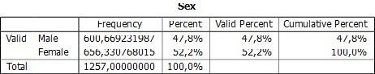
N 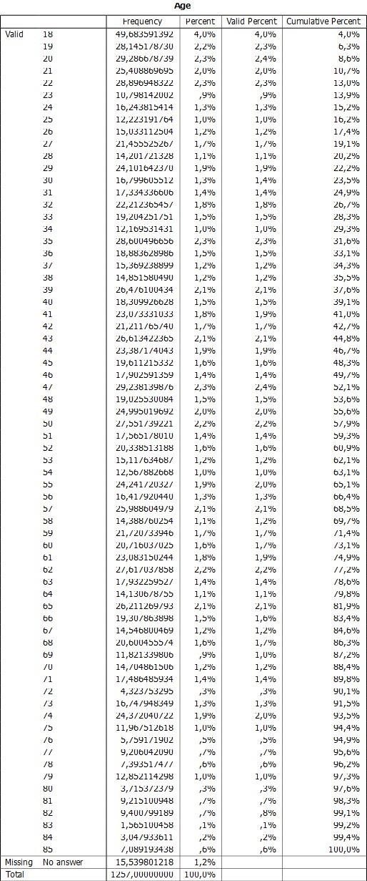

Annex 5: Important in life: Religion
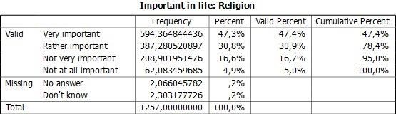

Annex 6: Religious person
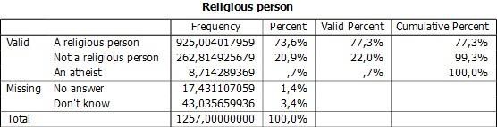

Annex 7: Confidence: Churches


Annex 8: Justifiable: Abortion
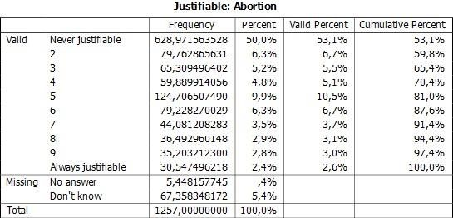

Annex 9: Men make better political leaders than women do
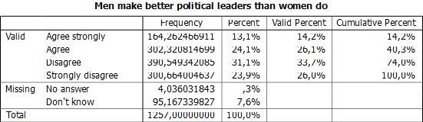

Annex 10: Men make better business executives than women do
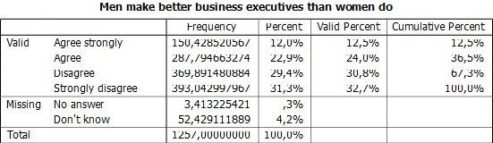

Annex 11: Relationship between the sex of the respondents and religion
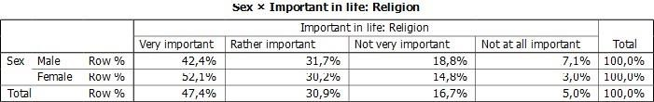

Annex 12: Relationship between the sex of the respondents and the degree of religiosity
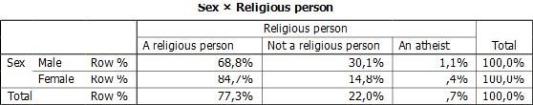

Annex 13: Relationship between the sex of the respondents and the degree of confidence in churches
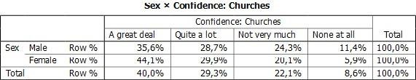

Annex 14: Relationship between the sex of the respondents and the degree to which abortion is perceived as justified
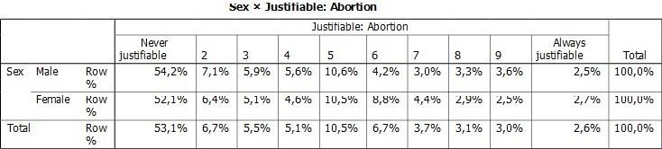

Annex 15: Relationship between sex and men and women in business positions
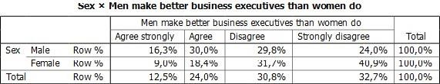

Annex 16: Relationship between sex and men and women in political positions
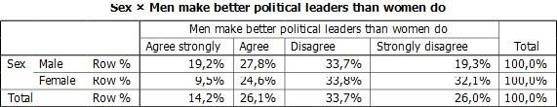

Annex 17: Bivariate Analysis
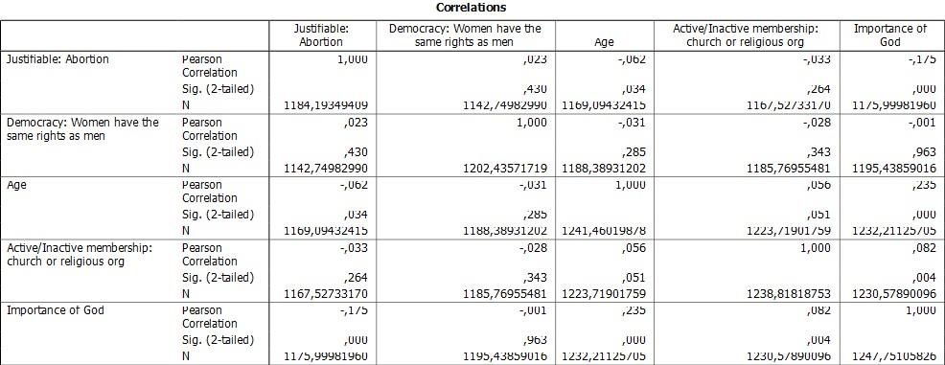

BIBLIOGRAPHY

Anton, L. 2018. "Forgetting Pronatalism? Abortion Governance and Pro-life Discourses in Post-communist Romania." ANTROPOLOGIA 5 (2): 56-74. Accessed December 23, 2023. https://www.ledijournals.com/ojs/index.php/antropologia/article/view/1457.
Apostol, N., and A. Iancu. 2012. Dreptul la avort și drepturi reproductive în Europa și România. Bucharest, Romania: Centrul FILIA. Accessed December 1, 2023. https://centrulfilia.ro/new/wp-content/uploads/2019/06/Dreptul-la-avort-sidrepturireproductive-in-Europa-si-Romania.pdf.
Băluță, O. 2011. "Impactul crizei economice asupra femeilor." In Impactul crizei economice asupra femeilor, edited by O. Băluță, A. Bragă, and A. Iancu, 9-41, 78-98. Bucharest, Romania: Maiko.
Bazele concepției sociale ale Bisericii Ortodoxe: Extrase. n.d. Bucharest, Romania. Accessed December 12, 2023. https://www.provitabucuresti.ro/docs/bioetica/bazeleconceptieisociale-bisericii-ortodoxe.pdf.
Bragă, A. 2018. "Sănătatea reproductivă și drepturi sexuale în România." Accessed January 8, 2020. https://centrulfilia.ro/sanatate-reproductiva-si-drepturi-sexualeinromania/.
Bragă, A. 2019. "Avortul - un drept legiferat, dar greu de accesat în România anului 2019?" Centrul Filia. Accessed December 25, 2023. https://centrulfilia.ro/avortul-un-drept-legiferat-dar-greu-de-accesat-inromaniaanului-2019/.
Buletinul Oficial. 1966. "DECRET Nr. 770 din 1 octombrie 1966 pentru reglementarea întreruperii cursului sarcinii." Romania: Consiliul de Stat al Republicii Socialiste România. Accessed December 20, 2023. http://legislatie.just.ro/Public/DetaliiDocumentAfis/177.
Codul penal - art. 201. 2009. "Codul penal." Parlamentul României. Accessed December 27, 2023. http://legislatie.just.ro/Public/DetaliiDocumentAfis/109855.
DECRET Nr. 770 din 1 octombrie 1966. 1966. Accessed December 12, 2023. http://legislatie.just.ro/Public/DetaliiDocumentAfis/177.
Dugulescu, M., and S. Barbu. 2012. LEGE privind înființarea, funcționarea și organizarea cabinetelor de consiliere pentru criza de sarcină. Romania: Parlamentul României (Camera Deputatilor și Senat).
Franț, A. E. 2014. "Abortion and Theology - An Impossible Conciliation?" Journal of Public Administration, Finance and Law 6: 269-279. Accessed January 23, 2024. https://www.semanticscholar.org/paper/ABORTION-AND-THEOLOGY%E2%80%93-AN-IMPOSSIBLE-CONCILIATIONFran%C5%A3/6b087f0c73aca3d30f6a1858e8c255b29e0e4368.
How Sociologists View Social Problems: The Abortion Dilemma. n.d. MySocLab. Accessed December 26, 2023. http://faculty.collin.edu/lstern/HENSLIN-SOCIAL_PROB_CH1.pdf.
Indicatori cantitativi legați de avort în România: Perioada de „avort liber” (1958-1966); Perioada de restricții (1967-1989); Perioada post-89. 2019. Statistica istorică a avortului în România. Bucharest, Romania. Accessed January 24, 2024. https://provitabucuresti.ro/docs/stat/statistici.avort.ro.pdf.
Întreruperi de sarcină. 1967-1989. n.d. Institutul Național de Statistică. Accessed January 25, 2024. http://statistici.insse.ro/shop/?page=tempo3&lang=en&ind=POP201G.
Întreruperi de sarcină. 1990-2017. n.d. Institutul Național de Statistică. Accessed January 23, 2024. http://statistici.insse.ro/shop/?page=tempo3&lang=en&ind=POP201G.
Johnson, J. E., and J. Robinson. 2003. "Living with Gender in Post-communism in Central and Eastern Europe." Unpublished.
Kligman, G. 2000. "Legiferarea reproducerii în Socialism." In Politica Duplicității. Controlul reproducerii în România lui Ceaușescu, translated by M. Dumitrescu, 53-99, 124-130. Bucharest, Romania: Humanitas. Accessed January 23, 2024. https://www.academia.edu/15412131/Gail_Kligman-Politicile_duplicitatii.
LEGE nr. 140 din 5 noiembrie 1996 pentru modificarea şi completarea Codului penal. 1996. Parlamentul României. Accessed January 29, 2024. http://www.cdep.ro/pls/legis/legis_pck.htp_act?ida=8679.
Miroiu, M. 2004. "Nevoia teoretizării feministe a politicului; Comunism, Postcomunism." In Drumul către autonomie, 44-230. Bucharest, Romania. Accessed January 23, 2024. https://www.academia.edu/1541266/Drumul_catre_autonomie.
Nagle, J. 2016. "Sociological Imagination." In Introducing Sociology: A Graphic Guide, edited by C. W. Mills and K. Jamison, 8-9. United States: Icon Books Ltd.
Okin, M. S. 1991. "Toward a Humanist Justice." In Justice, Gender and the Family, 171. Basic Books Inc. Publishers.
Redacția. 2024. "Politica pronatalistă a lui Nicolae Ceaușescu." Historia. Accessed January 23, 2024. https://www.historia.ro/sectiune/general/articol/politica-pronatalista-a-luinicolaeceausescu.
Thorpe, C., C. Yuill, M. Hobbs, M. Todd, S. Tomley, and M. Weeks. 2015. "Many Personal Troubles Can Be Understood in Terms of Public Issues." In The Sociology Book, 48-49. New York, United States: Penguin Random House.

