Semiotic Model of “Figure” and “Image” in Homo sapiens sapiens
Walter A. Monjes 1, Mirta Rachid 2
1 Faculty of Philosophy and Letters/Faculty of Arts/ National University of Tucumán, Argentine
2 Faculty of Biochemistry, Chemistry and Pharmacy/ National University of Tucumán, Argentine
artes.walter.monjes@webmail.unt.edu.ar
Abstract.
Semiology is structured into paradigms that were founded in the late 19th century (Saussure, Peirce, etc.) and the 20th century (Barthes, Eco, etc.); currently, with biolinguistics, there has been an attempt to confront the various parameters proposed by different sciences. These paradigms have sought to explain the function of the sign in human communication. These models are perfectly functional within each area of knowledge, but when they are confronted across different spaces of knowledge, they become inconsistent. The objective of our study is to generate a new sign model that integrates the five levels: non-sign (non-existence), operant sign (presents), animal sign (figurative), human sign (imaginary), and socialized human sign (symbolic), in which human thought develops. The methodological parameters used were: theoretical-qualitative, non-experimental, cross-sectional, and deductive, with observation, comparative documentary study, and validation through the abductive system. The results demonstrated that four types of signs coexist in Man (the 5th, excluded, is the non-existent sign): a sign that “presents” itself (operative figurative sign), an "instinctive animal" sign (figurative sign), a "humanized" sign (imaginary sign), and a "socialized imaginary" sign (symbolic sign), which are presented through the senses, amplified through practice, and mentally processed in infinite imaginary re-creations. In conclusion, we propose a new functional sign model in Man. This model presents the appearance of the figurative sign that becomes existence in the mind (through the senses), develops conceptually (in the mind), is re-con-figured (mental field process), and is transferred to the collective imaginary (symbol), allowing Man to transform strategies for supremacy.
Keywords: paradigm; sign; semiotic; thought/imagination; animal/human

Introduction: Epistemic approach and presentation of the problem
Research aims to elucidate the function that signs fulfill in the mind of modern man, Homo sapien sapien (HSS), which are presented through the perceptive senses in all animals (including man) and develop in the mind, according to the cognitive capacity of each individual. Predecessor models, such as the one presented by Plato (Cratylus, 240 B.C./1871, p. 383), explained that giving a “name to the sign” was a problem, since man has the need to separate the concept of one “name” from another “name”; therefore, they were assigned a sign that differentiated them: the “proper name.” In this way, for Man (HSS), this proper name «...gives a mental figure that signically differentiates “Juan” from “Pedro”; what is interesting about the name is that, if Juan’s proper name is changed to “José,” the sign that re-presents him (the name) changes, but the “presented referent” (the referred person) remains the same. Ferdinand de Saussure (1857-1913), through his “Signifier/signified” model, proposed the idea that every sign possesses an immovable “concept” (the referent) and an “acoustic image” in thought. This acoustic image varies in each thinker. The author explains that the sign TREE has only one concept, but each thinker will imagine a “different tree.” Charles Sanders Peirce (1839-1914), in his model, defines:
«A sign, or representamen, is something which stands to somebody for something in some respect or capacity. It addresses itself to somebody, that is, creates in the mind of that person an equivalent sign, or perhaps a more developed sign» (1994, [1897], p. CP 2.228).
Peirce proposes an “Interpretant” (of the referent) and that this “Interpretant” also generates another “more developed equivalent sign.” In this model, the Interpretant re-creates multiple “Representamens” through a process of resignification or semiosis. The limitation of this model is that it does not specify the creation of signs devised by man. Ernst Cassirer (1874 - 1945) made important contributions to humanized thought, where he proposed his theory of man as a «symbolic animal». In his model, Cassirer argued that man has, unlike animals, an expansive capacity in the act of “thinking,” a capacity that “presents” itself as a stimulus/response and generates a «symbolic-sign» that allows HSS to cover their vital biological needs. Charles William Morris (1901-1979), an American philosopher and semiotician, made numerous contributions to the theory of signs and semiotics. In his work “Foundations of the Theory of Signs” (1938), he laid the foundations upon which he would later develop his neopragmatist philosophy. Morris interprets the sign based on the study of social man, considering him a “symbolic animal,” a concept that coincides with and was extensively developed by Ernst Cassirer. His theoretical model is formed by: «components of semiosis which may be called, respectively, the “sign vehicle [S]”, the “designatum [D]” and the “Interpretant [I]”; the “interpreter [i]” could be considered a fourth factor» (Morris, 1985 [1938], p. 27). In this model, Morris explains that:
«The most effective characterization of a sign is as follows: S is a sign of D for I to the extent that I takes D into account by virtue of the presence of S. Therefore, in semiosis something takes something else into account immediately, that is, through a third something» (1985 [1938], p. 28).
With these concepts, Morris developed a grammar in which he conceived three relations: the «syntactic dimension» which is given by the relation (S-S), the «semantic dimension», which relates (S-D), and the «pragmatic dimension», proposed as (S-I). Here we can observe that the “sign vehicle,” which for Morris «is the manifestation of the sign» is very similar to Peirce's “representamen,” but with another name, as it alludes to the forms that a referent can take, which “carries” its significance. On the other hand, Morris proposes a model in which the «designatum» is «that to which the sign refers», that is, the real foundation (e.g.: horse), but with the caveat that it «accounts for those `designata´ without a real referent» and unreal foundations (e.g.: unicorn). Again we observe a synonymy to Peirce's “representamen,” since the “designated object” by the “sign vehicle” refers to existences without essence (for example: a god). Finally, the “interpretant” [I], which he refers to as «the observable behavior triggered in the receiver», brings it closer to Ferdinand de Saussure's “concept,” which allows it to be interpreted as the “concept.” That is why Morris cannot configure the basic structure of [S], [D], and [I], which includes [i], into a triptych model. The author separates the «interpretant» [I], which possesses the capacity to read the “concept” of the «signic manifestation» [S], from the «designatum» [D] through the «interpreter» [i], where he separates [I] and [i] and places them in two dimensions, where the «interpretant» [I] has the capacity to “identify” the foundation, while the «interpreter» [i] assigns the concept according to a social function. In 1964, Roland Barthes (1915-1980) proposed in “Rhetoric of the Image” (1986 [1964], p. 29) a new visual sign literacy that should be studied from the «Syntagms/System» duality. The model proposed by Barthes presents a structure based on «three levels of visualization» of the sign: a.- «The linguistic message»: which he considers a true set of ritualized signs or texts (symbols) that are incorporated by the “visual sense” and are also interpreted as mental images; b.-«The denoted message»: in which he refers to the acquisition of the sign concept (e.g.: tomatoes), in a “literal” manner, an «analogon» of nature that can be presented and perceived without the incorporation of any valuation. It is a primary communication that is received -factically- from other existences without presuming the effects that this may entail; and c.- «The connoted message»: where the receiver gives an interpretation of the visual according to their cognition, thus incorporating a valuation that experience grants (e.g.: “Italianness of the tomato sauce”). Umberto Eco, (1932-2016) in the “A Theory of Semiotics” (Eco, 2000 [1976]) proposes «to outline two (dialectically interdependent) domains of a semiotic discipline: a theory of codes and a theory of sign production» (Eco, 2000 [1976], p. 11). In these models, it is observed that these domains will have crossings and inversions of structural order (chiasmus) where he relates five aspects of the sign and communication: 1.- he differentiates signification from communication; 2.- he introduces a theory of the referent; 3.- he attempts to unite semantics and pragmatics into a single model; 4.- he criticizes the concept of sign from the Peircean typology; and 5.- he questions the arbitrary conventionality of the icon. We have analyzed points 2, 4, and 5, and the concept of «ideas as signs» (Eco, p. 349), and we performed a comparative analysis of the differences between the structures of figure and image.
From linguistics, semiology, and communication among other sciences, different models have been developed that explain the function of the sign.

Objetive
The objective of our study is to generate a new sign model that integrates the five levels: non-sign (non-existence), operant sign (presents), animal sign (figurative), human sign (imaginary), and socialized human sign (symbolic) in which human thought develops.

Material and Method
In this research work, the following analytical system was used: theoretical-qualitative, non-experimental, cross-sectional, and deductive, with observation, comparative documentary study, the making of proposals, and validation through the abductive system.
The methodology used for this work was selected based on the fact that etymological and epistemic analyses present a problem of meta-definition, which results in its own entity. Therefore, signifying the sign through a signification with fewer parameters within the system could bias the study toward self-referentiality.

Next, we will develop all the results obtained in our studies with the aim of generating a new sign model that explains the stratification in four functional levels in which the sign performs and develops in the mind of Man, and a fifth that is not incorporated. These are: 1) non-sign (non-incorporated non-existence), 2) operant sign (presents itself), 3) animal sign (figurative), 4) human sign (imaginary) and 5) socialized human sign (symbolic). The results of these studies demonstrated that four of the five types of signs coexist in Man: 1) a sign similar to any entity (operant sign); 2) an “instinctive animal” sign (figurative sign), 3) a “humanized” sign (imaginary sign) and; 4) a “socialized imaginary” sign (symbolic), which are presented through the senses, are amplified through practice in HSS and are mentally processed in infinite imaginary re-creations, to later be re-signified socially as a symbol of power.

The comprehension of the no-sign
Could an example of a non-meaning be given?
Some authors have tried to analyze the concept “non-sign”. The most representative example is Barthes (Elements of Semiology, 1971 [1964]) (1986 [1964]) when he explains the «degree 0» (of the sign) and exposes it as «a problem posed by the privative oppositions of the “unmarked” term which he calls the `zero degree´ of the opposition.». Furthermore, Barthes confirms his contradiction by endorsing the quote from Destouches: «“A” is in a zero state, that is, “A” does not effectively exist, but, under certain conditions, it can be made to appear» (p. 77). Here he incurs a new contradiction.
From our analysis, we think that: “A” is already a “sign” by its being (existence marked with “A”), and it cannot be considered that it “does not effectively exist” as Barthes expresses. For us, the sign “A” in its “zero state” (non-existence for Barthes), would only be an “unknown sign” or an “absent sign” in cognition. What Barthes expresses generates ambiguity, because he confuses a sign absent in the mind with a non-existence (“not marked with A”); and second, he expresses that “under certain conditions, it can appear” a sign without the intervention of memory or perception. We believe that it is not possible to create ”A” and give it a meaning from “nothing”. The human mind can only perform mental field processes from the two unavoidable components of signification: perception and memory. Both are necessary to be able to “think significantly” and generate re-signified meanings. For example, a set of “meaningless” lines, dots, and spots like the works of Miró or Kandinsky, can be re-created in each person's mind and interpreted in different ways (paths, people, animals, etc.) depending on their memories of these and not of the authors of the works.
There is no definition in the Spanish language for the meaning non-sign or an antonym of “sign” to be able to elucidate the “non-meaning”. But, in the English language appear some antonyms of sign such as: “misindication”, which refers to the lack or poor indication; “misrepresentation”, which alludes to a deviation, distortion or confusion and “misleader”, which refers to deception or falsehood. These meanings provide concepts that are not true oppositions to the term “sign”. This extends to other languages because we think that a non-signification cannot be felt by the senses, nor perceived in the mind; it is a concept that cannot be included in a dictionary, because if it is signified it will cease to be a non-meaning. It is nothing, but without the concept of emptiness that nothing carries as a signification; it is a non-existence that is not in the mind (Level 0).
After having analyzed the different models before mentioned, we have observed that the non-sign and the “non-existences”, are concepts that could be “understood” as: all those signs still 'not appeared' in the perceptions and in the cognition of a particular individual. In this definition, the concept of “non-existence” is only the cognitive ignorance of something that exists and signifies, but that has not yet been perceived in the mind of HSS. From this point of view, the“non-existence” can only be defined as an unknown existence. For example: an atheist person cannot take away the meaning from the word “God”, because they already possess the concept in their cognition, and they cannot dismiss the sign “A” (expressing: “God does not exist”) because they have already left Level Zero and it exists in their memory (fig. 1- Level 0).
1st axiom: The “non-sign” is the antithesis of the definition of a signic non-existence in the realm of the human mind.
Figure 1: (Monjes; 2023)
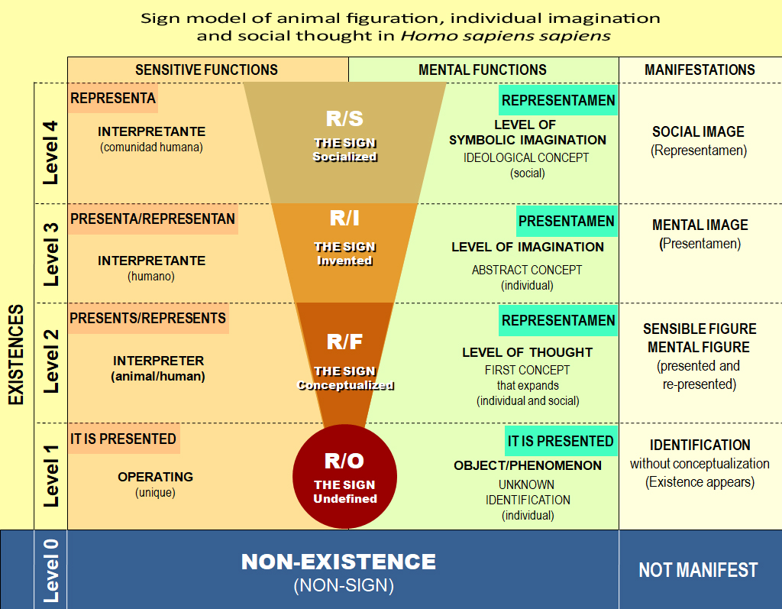

The Operative Referent (R/O) as the existence appeared in the HSS
The first time an object or phenomenon (o/p) is presented as an “unknown thing” through the senses (hearing, sight, smell, touch, or taste), it is immediately recorded in the memory of any higher animal. The (o/p) is transformed into a sign when it is perceived for the first time. This sign (Level 1) has a basic level of arbitrary significance that identifies the «foundation» (o/p), which has no «representamen», as it is a presentamen in the mind; and from now on we will call it Operative Referent (R/O). Our concept of referent is not on the same plane assigned to it by Peirce. For this author, the referent (or ground) is one part of a triadic sign along with the representamen and the interpretant. From our research, the referent is a sign that stands apart from its representations, as the referent cannot represent itself, it only presents itself as the R/O. This referent without a concept (R/O) is acquired by the entity, and the mind immediately performs a task that compares the unknown R/O with the signs already conceptualized in the memory. In this way, the HSS will give it a first significance, which may or may not be accurate; and which may change and develop through praxis (Fig. 1 – Level 1).
2nd axiom: The Operative Referent (R/O) is an object or phenomenon that presents itself as a basic sign in the receiver, which becomes an existence in the mind of the HSS.

The Figurative Referent (R/F) as a conceptual expansion of the R/O
After the first identification of the R/O by the instinctive thought of the HSS, the R/O moves on to be conceptualized in a 2nd Level: the Figurative Referent (R/F). In this 2nd level, the R/F will accumulate data through the experiences acquired with said sign; that is, whether the R/F is beneficial, indifferent, or harmful to the subsistence of the being that experiences it (man/animal). Nonetheless, these first concepts acquired by the R/F may or may not change. For example, a bird (or a man) when discovering a new fruit (R/O), assigns it a mental figuration of comparative identification with its memory reserve (foods). Then, if upon eating it the being suffers indigestion, the fruit (R/F) will acquire a new concept of “Non-edible fruit.” Although the R/O remains “Fruit,” thought re-conceptualizes it into the R/F, from “edible” to “non-edible.” In each experience with the R/F sign, man/animal will accumulate new information in the memory: places, cycles, ripeness, etc. These data, stored in the memory, will impose an expansion on the conceptual meaning of the R/F, but always without changing the R/O concept. It is for this reason that in our Model, the R/F is demarcated as an inverted triangle, showing the conceptual development that each figurative sign possesses in the individual's cognition, whether through practice or imitation (Fig. 1 – Level 2). For example, a hatchling learns —by instinct— to escape from a predator or by imitation of its peers; likewise, a child learns through personal experience, verbal teaching, or imitative practice to re-signify the Rs/Fs. Entities that do not know how to distinguish between signs that favor or disfavor subsistence have fewer possibilities to develop and reproduce in the environment.
Once an animal, as a cognitive unit, accumulates different figurations and stores them in its memory at different moments (T1, T2, T3, Tn…), it will subsequently be able to compare them in an endotopic communication with the isometries and isomorphisms of the R/Os received from the environment at each instant of its present and from the accumulated life experiences (Monjes, 2023). Over time, the entity will increase the cluster of Rs/Fs stored in its memory; thus, entities with more life span will have greater cognition (informative cluster of R/F) to compare and act accordingly. When new figurations appear, man/animal will be able to act by effect with greater certainty. In the transtopic communication that occurs between individuals of the same species, an R/F can be transferred, which will be utilized by the group. When the R/F is presented in the environment for the subsistence of man/animal, the latter configures it as a usable or discardable concept. This 2nd Level of interpretation in animal thought (including the HSS) is based on the individual mental utilization of Rs/Fs and on the figurative re-presentations in the groups that perceive it. For example, if a bird —within a flock— notices danger, it flies; then the rest of the flock will imitate this reaction, regardless of not having previously identified the referent as an indexical sign (Monjes, 2023).
3rd axiom: Every Figurative Referent (R/F) is a sensible manifestation that is presented in nature and re-presented in memory, where it develops conceptually in all animals (including the HSS); and whose signic utility is subsistence through logical “thought.”
The R/F will always be determined by that first experience of presence accumulated in the mind and can only be conceptually re-presented in the mind of the “being” when it is perceived again. Thus, when the receiver perceives the Rs/Fs again in a presential manner (it presents itself in nature), he compares them with the Rs/Fs stored in the memory (they are re-presented in the mind), which in turn were incorporated as Rs/Os (identified in their first appearance). The R/O and R/F are one and the same sign developed with vital importance for the entities that perceive and think it. Then, the thought of man/animal makes decisions to act before signic presences. This determines that the sensory stimulus produced by R/O (identification of the referent) in the mind will give rise to the R/F (functional conceptual understanding) by memorizing the morphological figuration of the concept (similar to Saussure's “acoustic image”) in any sensitive animal and what Peirce calls «representamen».
4th axiom: The figurative referent (R/F) arises when an R/O is conceptualized as an expanding figurative re-presentation in the mind, which will endure in the memory and whose development will depend on the cognitive level of man/animal to ´think´ productively.

The re-creation of the Imaginary Referent (R/I) in the HSS
In the 1st and 2nd levels, the word “thought” has been used to determine the mental field work of animals (including the HSS), using the signs R/O and R/F for their experiences and subsistence.
In contrast, in the HSS, in addition to using these two signic levels (R/O and R/F), man acquires a new innate mental process, which allows him to use these figurations to re-con-figure them through extrapolation in the planes of thought (Monjes; 2023; see figs. 2 and 3). In this way, we propose a 3rd signic Level: The Image Referent (R/I), which is substantially different from the act of “thinking” (intelligent and reasonable). In this 3rd Level, the HSS produces a “mental field work” where he imagines new signs in nature up to that moment (re-creation).
The HSS has managed to re-combine parts or totalities of Rs/Os and Rs/Fs to re-construct a “new sign” not present in nature up to that moment. A sign that has not been perceived by the sensory organs (sight, smell, sound, etc.) and that has been obtained through a process of mental field (image), using metonymies, synecdoches, and metaphors that were stratified in the human mind to obtain that new imaginary sign (R/I). In this way, imagination is a mental field work that re-creates a new sign and that only the human brain can provide. From two or more figurations, it has been possible to create existences that were non-signs before being “imagined”. A process in which human thought expands creatively (Fig. 2 – Level 3). A new way of thinking that is fostered by neuronal connections that allow the generation of an Imaginary Referent. We have used the word image because the expression derives etymologically from the Latin: imago (magical or supernaturally created figure). This R/I is a true new sign appeared as an operative referent (R/O) but, in this case, the appeared sign was re-created in the human mind (an artificial sign).
Man makes it possible starting from the existing natural references in his cognitive universe and, from there, he creates artifacts through a mental abstraction, producing a new imagined existential referent, only visible in the reality of man. It is to be observed that although every man can imagine, it is no less true that such capacity will be expanded when he has a greater quantity of R/F signs in his memory. Pico Della Mirandola already foresaw the will to become humanized through learning when he expressed: «[...] according to how each man has cultivated them, they will ripen in him and give him their fruits. If he were vegetable, he will be a plant; if sensitive, he will be a beast; if rational, he will rise to a celestial animal.» (Oration on the Dignity of Man, 2006 [1486]). Although Pico Della Mirandola referred to man from a religious concept, it is significant that man is born with an animal thought, but his mental capacity allows him to develop as “human” through his learning. For example, we could cite the impossibility of someone having imagined a multiplication if they had not previously possessed the knowledge of the concept of addition; and the latter, before the concept of number. All these abstract signs (R/I) are invisible to the rest of the animals.
Figure 2: Signic re-creation of the Imaginary Referent (R/I) in the HSS. (Monjes; 2023)
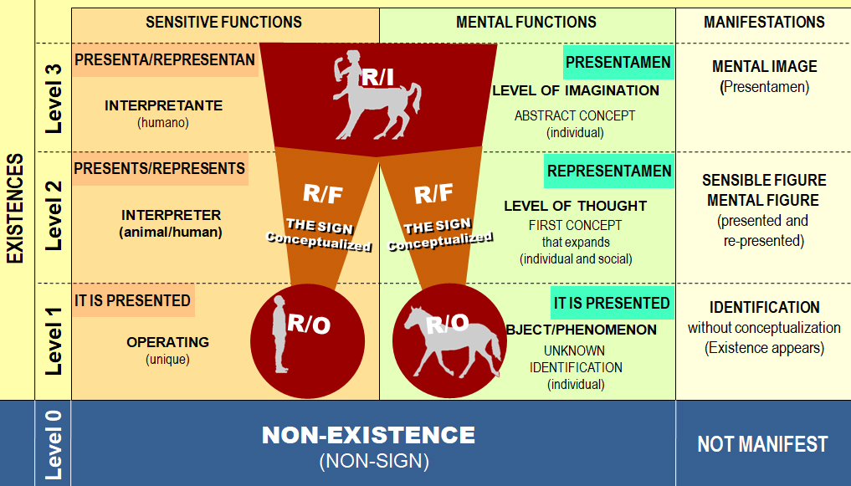
These new referents (R/I) do not depend on the senses or the presenciality of the R/F in the environment, but rather the HSS takes the R/F accumulated in his memory and re-con-figures them to con-form a new imaginary referent (R/I). This R/I is nothing other than a “mental reconstruction” of the new sign (invention), and it is still a non-sign in nature until it is communicated. At the moment the R/I is presented in the mind of the HSS, we call it Presentamen, as it occurs in present time in the mind of the imaginer. When the latter communicates the R/I to another person, it is transformed into a re-presentation (presenting again) (R/F). This mental re-presentation we have termed Representamen. For example, at some point, the “figurative” signs [man] and [horse] (Os/Rs and Fs/Rs), stored in the memory of a man, both were re-con-figured and re-created into a new signic image: the [centaur]. In this case, a mental field work was carried out to imagine the new referent, and this HSS identified it with the name “centaur” (R/O ↔ R/I) in order to share it with his peers as a figuration (R/F). This new sign of man can also be modeled and duplicated morphologically through the use of clay, cement, pencil, etc. (E.g.: a sculpture of the centaur = R/F).
5th axiom: The image referent (R/I) is a re-creation produced in the mind of the HSS that does not depend on sensors (sight, hearing, etc.), but on a mental field work that takes the figurative referents (R/F) contained in the memory and transforms them into new mental images non-existent in nature until that moment. The R/I becomes reality by being presented in the mind of the HSS (re-creator) as a “Presentamen” and communicating it as an R/F to another HSS as a “Representamen”.
The multiple figurations that are incorporated and reside in the memory plane of man allow him to use the different cognitive layers to form a new imaginary referent (R/I). For some physiological reason, new neuronal connections have been generated in the Homo sapiens sapiens that allowed him to link and diagram the figurations present in the different cognitive layers where the R/F are stratified and stored as sets of particular signs (food, people, animals, insects, etc.) (fig. 3 – color plane). Furthermore, the HSS can combine these sets of R/F and generate a new layer using R/F from each group; in this way, he re-creates a new sign that is integrated transversally to the R/F to obtain a new R/I [Sphinx] (fig. 3 – gray plane). A collateral mental field work that uses the superlative concepts of the figurations of each layer and re-con-figures them in a (fig. 1 - 3rd Level) into a new type of sign: the image.
Figure 3: Stratified thought of Rs/Fs (color planes) and transversal Imagination of R/I (gray plane) where the “presentamen” is re-created (white plane). (Monjes; 2023)
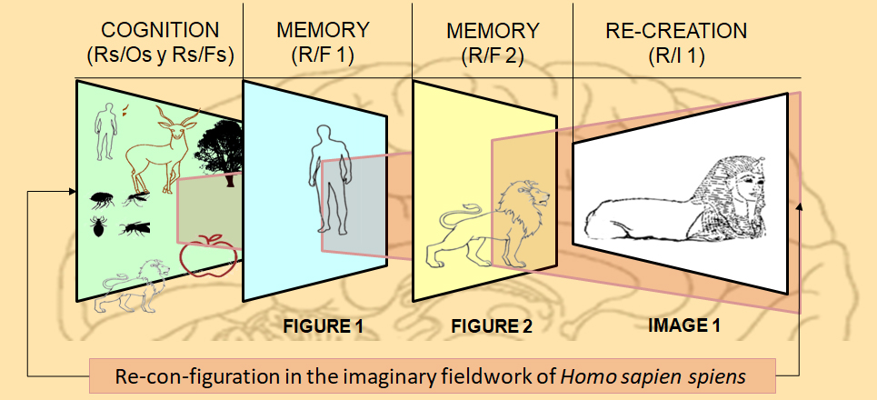
In this case, for example figure 2 shows us the image is a mental field work of HSS where he reconfigures the body of a lion (reality 1: natural - R/F1) and the head of a man (reality 2: natural - R/F2), both are joined to re-con-figure the Sphinx, a third artificial reality (R/I1), which may be transmitted to other men as an R/F3.
Man is not a permanent imaginer, but a subsistential thinker who only imagines when he has the need to solve a problem that has never before been developed and possesses the necessary and sufficient cognition for mental field work.
6th axiom: every sign-image is a new manifestation that presents itself (endotopically) in the man who creates it as an R/I (Presentamen) and is re-presented (transtopically) to other men as an R/F (Representamen).

The production of the image as a sign of power through the Symbolic Referent (R/S) among HSS
Man provides images to his community in an arbitrary manner; through this, the HSS acquires prestige and power. These images are not always distributed with a philanthropic character among HSS as Roman Gubert (1996) explains when he expresses: «the cryptic image», a true “lodge” that reserves the images that are figured so that the “uninitiated” perceive them, but they will only be understood (re-con-figured) by the lodge. Each civilization, each society, each human group has been characterized by withholding knowledge as a communicative act of power. This is why man, in certain fields of study, has always tried to signify symbolically only for those who have learned the symbol. From nations, Masonic lodges, doctors, engineers, chemists, and even chefs, they have tried “not to disclose their secrets” within their specific areas. They do not popularize their knowledge or their imaginary creations to other social niches because they use them as signs of power.
Our studies demonstrated that the HSS transfers the R/I to the group (a clan, a society, etc.) as a tool for subsistence. This transfer allows the participants to acquire a new meaning through a shared imaginary mental simulation that, if accepted by said community, is transformed into a Symbolic Referent (R/S), which will be valued and used for the common good “as a “social idea” (Fig 1 4th Level). This R/S will remain in society until it is replaced by another R/S that surpasses the previous one.
The R/S is an abstraction that proposes a “meaningless” and imposes a “social value” on it. For example, a stick (without value as a natural resource) can grant a symbolic value of power (Scepter) to the leader or the shaman of a certain clan; a symbolic meaning that will not be understood by the rest of the animals, nor by another community that has not granted it said symbolic value.
Therefore, imaginary creations (Rs/Is) must first be re-presented to the community through an R/F, to then be incorporated into the group's cognition as an R/S. These multiple agreements on the valuation of signs determine the culture of each community. This is why all the ideas transmitted from generation to generation must first pass through a social evaluation so that the new image is established in the community with its use and a social context. On the other hand, SR/Ss have always been and will be social impositions, regardless of the Os/Fs and the Rs/Fs, but rather the degree of R/S that is imposed. For example, one paper painted as R/S [Dollar] and another as R/S [Euro] with the number 100 will have different social values.
In the same way, the “attributes granted to leaders of all times” function; those who are transformed into R/S for the masses grant them (Jesus, Muhammad, the Dalai Lama, Gandhi, etc.) or the SR/Ss are imposed by force (Alexander the Great, Gaius Caesar, Attila, Stalin, etc.). A power exercised by the SR/Ss that delimits social behavior.
We emphasize that the evolutionary development of the HSS was determined by a community selection of the individually created Rs/Is and subsequently socialized through an R/S that arbitrarily persists over time and allows for the learning and technological development of men that are invisible to the rest of the animals.
7th Axiom: The created Rs/Is that are transferred and accepted as new R/F by a community become R/S, which allow for learning and technological development in the HSS.

Conclusions
We present a new model of the sign, which is determined by the following parameters:
• The first conception of a sign is the appearance of “something” that until that moment was a non-existence and that becomes existence.
• The first meaning of the sign is the identification of the unknown “thing” (object/phenomenon), which differentiates it from all known signs in the memory records of any higher animal (vertebrates). This identified but not conceptualized sign is the operative referent (R/O) and it presents itself in the life of the receiver.
• When the acquired R/O is conceived with qualitative and quantitative significations that can be thought of productively for the survival of animals, we call them figurative referents (R/F).
• The processes of an instinctive thought that identify the R/O and signify it productively as R/F occur in all animals (including the HSS). At this level, animal thought has the capacity to figure the R/O and to con-figure (figure again) through the instinct of conservation.
• The HSS is the only higher animal that has the innate capacity to use the Rs/Fs incorporated in its cognition and can re-con-figure artifacts in a particular way: re-creating imaginary referents (R/I). At this level, man has the power, in the first instance, to think the R/F and, in the second instance, to imagine another R/O↔R/I non-existent until that moment, through the generation of a mental field work.
• Man possesses the genetic capacity to produce mental images that are not caused by praxis or imitation; they are true technological creations that evolve in the mind of the HSS, re-using the knowledge that resides in the memory and that is forbidden in the thought of the rest of the animals.
• The Rs/Is that man imagines, if they are transmitted and accepted by the community, will foster abstract constructs that are utilized by society as Symbolic Referents (R/S). At this level, the symbolic sign becomes part of the cultural values that will transform the reality of said society.

Acknowledgments
This research work was carried out at the Institute for Research in Communication Sciences (ININCCO) of the Faculty of Philosophy and Letters; Faculty of Arts and the Faculty of Biochemistry, Chemistry and Pharmacy of the National University of Tucumán. Argentine Republic. It was conducted with the financial support of the Secretariat of Science and Technology of the National University of Tucumán (CIUNT), within the framework of the Research Project PIUNT (H728-2023-2026) based on the origin of human thought, under the Directorship of Dr. Walter A. Monjes, who thanks all these Institutions.

References
Barthes, R. (1971). Elements of semiology. “Rhetoric of the image” [Elementos de la Semiología. ”Retórica de la Imagen”] (A. Mendez, Trans.; Original work published 1964). Alberto Corazón.
Cassirer, E. (1967). An essay on man: An introduction to a philosophy of human culture [Antropología Filosófica. Introducción a una filosofía de la cultura] (5th ed.). Fondo de Cultura Económica.
Cassirer, E. (2016). Philosophy of symbolic forms I: Language [Filosofía de las formas simbólicas I El lenguaje] (A. Morones, Trans.; 1st electronic ed.; Original work published 1923). Fondo de Cultura Económica.
de Saussure, F. (1945). Course in general linguistics [Curso de Lingüística General] (Original work published 1916). Lozada.
Eco, U. (2000). A theory of semiotics [Tratado de Semiótica General] (C. Manzano, Trans.; Original work published 1976). Lumen.
Gubern, R. (1996). The scene and the labyrinth [La escena y el laberinto]. In R. Gubern, From bison to virtual reality [Del bisonte a la realidad virtual]. Anagrama.
Monjes, W. (2010). Communication model in living beings: From the endotopic to the transtopic [Modelo de comunicación en los seres vivos: desde lo endotópico a lo transtópico]. In X. C. REDCOM (Ed.), The challenges of social communication and journalism in the bicentennial. XII REDCOM Congress.
Monjes, W., et al. (2017). The power of man through the image [El poder del hombre a través de la imagen]. In W. Monjes (Ed.), Stories and discourses from positions of power [Relatos y discursos desde las posiciones de poder] (pp. 55-77). Instituto de Ciencias de la Comunicación.
Monjes, W. (2023). The image as a theoretical foundation of a communicative grammar. The communication of the image and the development of differential thought in Homo sapiens sapiens [Doctoral dissertation, National University of Tucumán]. Library of the Faculty of Philosophy and Letters - UNT.
Morris, C. (1985). Foundations of the theory of signs [Fundamentos de la teoría de los signos] (Original work published 1938). Paidós.
Peirce, C. S. (1994). Collected papers of Charles Sanders Peirce (J. Deely, Ed.; Electronic ed., Vols. 1-8; Original work published 1897).
Pico Della Mirándola, G. (2006). Oration on the dignity of man [Discurso sobre la dignidad del hombre] (Á. Lobo, Ed.; Original work published 1486).
Plato. (1871). Cratylus [Cratilo] (P. Azárate, Trans.; M. y Navarro, Ed.; Philosophical Library ed., Vol. II; Original work published ca. 360 B.C.). Biblioteca Filosófica.
Plato. (1871). The Sophist [El Sofista] (E. & M. y Navarro, Trans.; Vol. II; Original work published ca. 360 B.C.). Biblioteca Filosófica.

