Relational vs Self-Focused Death Anxiety: Big Five Correlates in an Albanian Community Sample
Briseida Andoni¹, Ergi Bardhollari¹, *Rea Goga¹
¹European University of Tirana, Tirana, Albania
*Corresponding author
Abstract.
Background: Most evidence on Big Five correlates of death anxiety comes from Western samples, leaving cross-cultural generalizability uncertain. We tested whether trait–mortality links replicate in Albania while separating fear of one’s own death from fear of others’ death.
Method: Albanian adults (N = 530; 80% female; age 18–58, M = 24.9) completed the BFI-2-S and the revised Collett–Lester Fear of Death Scale (two 7-item subscales). Analyses prioritized effect sizes (95% confidence intervals), correction for multiple testing, and equivalence testing to interpret null associations.
Results: Neuroticism related to fear of one’s own death (r = .17, 95% CI [.09, .26]) and Agreeableness related to fear of others’ death (r = .13, 95% CI [.05, .21]); both survived Bonferroni correction (p < .005). Other traits showed small, non-significant associations; Conscientiousness and Openness (for fear of own death) were statistically equivalent to negligible effects (|r| < .10). Descriptively, fear of others’ death was substantially higher than fear of one’s own death (M = 4.20 vs 2.98 on a 1–5 scale), suggesting a relationally weighted mortality concern. Religious affiliation did not differentiate either dimension.
Conclusion: Trait correlates of death anxiety appear dimension-specific in Albania, with notable emphasis on relational mortality fear; longitudinal work is needed to test mechanisms and temporal ordering.
Keywords: Albania; Big Five; death anxiety; fear of death; personality

Introduction
Death anxiety is clinically consequential and theoretically central to existential psychology, yet its expression is shaped by both dispositional factors and cultural meaning systems. Across traditions, people simultaneously acknowledge mortality and defend against it through denial, symbolic continuity, and relational anchoring (Becker, 1973; Yalom, 1980). In contemporary research, death anxiety is often operationalized as a multidimensional construct rather than a single global fear, with separable concerns about one’s own death and the death of significant others (Collett & Lester, 1969; Lester, 2004). These dimensions differ phenomenologically: fear of one’s own death centers on bodily vulnerability and personal nonexistence, whereas fear of others’ death is strongly relational, often overlapping with attachment threat and anticipatory grief (Mikulincer & Shaver, 2008; Stroebe & Schut, 2001).
Within the Five-Factor Model, Neuroticism has repeatedly emerged as the most consistent correlate of death anxiety, aligning with heightened negative affectivity, threat vigilance, and catastrophic interpretation of internal cues (Iverach et al., 2014; Watson & Clark, 1984). Proposed protective pathways include Extraversion via social connection and positive affect (Lucas & Diener, 2001) and Conscientiousness via perceived control and future-oriented planning (Bogg & Roberts, 2004). However, the literature is heavily weighted toward Western, educated, industrialized, rich, democratic (WEIRD) samples, raising the likelihood that “known” associations are partly context-bound rather than universal (Henrich et al., 2010).
Albania offers an informative context for testing boundary conditions. It is characterized by strong family interdependence, religious pluralism with varying degrees of practice, and rapid sociocultural transition. In such settings, death anxiety may be organized more around relational loss than solitary extinction, potentially altering which traits matter and for which mortality dimension. In other words, the key empirical question is less whether Neuroticism correlates with death anxiety somewhere in the world and more whether trait–mortality links replicate, with what magnitude, and for which dimension of fear when the cultural ecology shifts.
Accordingly, the present study is positioned as a replication-with-extension. It tests the association between Big Five traits and two death-anxiety dimensions in an Albanian community sample, while adding a precision-oriented analytic approach that reduces reliance on directional claims that cross-sectional designs cannot justify. We hypothesized that (H1) Neuroticism would positively relate to fear of one’s own death and (H2) Agreeableness would positively relate to fear of others’ death. We additionally explored whether religious affiliation differentiates death-anxiety scores, given mixed prior findings on religiosity and mortality fears (Park, 2010; Steger et al., 2006).

Method

Participants and procedure
Participants were Albanian adults recruited online via social networks and academic platforms using purposive and snowball sampling. Inclusion criteria were age 18–58, Albanian-language fluency, and provision of electronic informed consent. The final sample comprised N = 530 respondents (80% female; 18% male; 2% other/unspecified; age M = 24.9, SD = 5.29). The survey was anonymous, uncompensated, and required approximately 5–10 minutes to complete. Data were stored in encrypted form and analyzed in aggregate.

Measures
Personality was assessed with the Big Five Inventory-2 Short Form (BFI-2-S; Soto & John, 2017), a 30-item measure of Neuroticism, Extraversion, Openness to Experience, Agreeableness, and Conscientiousness. Items were rated on a 5-point Likert scale (1 = strongly disagree to 5 = strongly agree). Domain scores were computed as mean item scores after reverse-scoring negatively keyed items. Internal consistency in the present sample was acceptable (Cronbach’s α = .72–.84 across domains).
Death anxiety was measured with the revised Collett–Lester Fear of Death Scale (CL-FODS; Collett & Lester, 1969; Lester, 2004). We used two 7-item subscales: fear of one’s own death and fear of others’ death. Items were rated from 1 (not at all afraid) to 5 (extremely afraid), and subscale scores were computed as means. Both subscales showed good reliability (α = .85 for fear of own death; α = .88 for fear of others’ death).
All instruments were translated into Albanian using forward translation and back-translation, followed by pilot testing to ensure linguistic clarity and conceptual equivalence.

Analytical strategy (methodological emphasis on precision)
Analyses were conducted in IBM SPSS Statistics (v.27). We reported descriptive statistics (means, SDs) for all variables and used Pearson correlations to estimate associations between traits and death-anxiety dimensions. Given the cross-sectional design, we interpret associations as correlational, not directional.
To address concerns about “novelty” being driven by p values rather than magnitude, we complemented NHST with (a) 95% confidence intervals for effect sizes, (b) a Bonferroni adjustment for multiple correlation tests (α = .005 for 10 trait–outcome pairs), and (c) equivalence testing for null effects using a smallest effect size of interest of |r| = .10 (Lakens et al., 2018). For additional interpretability, we also computed Bayes factor approximations based on the Bayesian information criterion (BIC) to quantify relative evidence for an association versus the null (Wagenmakers, 2007).

Ethics
The study followed the Declaration of Helsinki (World Medical Association, 2013). Participation was voluntary, anonymous, and involved no deception or collection of identifiable data. In line with minimal-risk guidance under institutional and national norms, formal IRB review was waived. All participants provided electronic informed consent prior to participation.

Results

Descriptive statistics
Table 1 summarizes descriptive statistics for personality traits and death-anxiety dimensions. Participants reported moderate fear of their own death (M = 2.98, SD = 1.12) but high fear of others’ death (M = 4.20, SD = 0.69) on a 1–5 scale.
Variable | M | SD
Extraversion | 3.43 | 0.66
Agreeableness | 3.52 | 0.52
Conscientiousness | 3.75 | 0.59
Neuroticism | 2.96 | 0.73
Openness to Experience | 3.61 | 0.58
Fear of own death | 2.98 | 1.12
Fear of others’ death | 4.20 | 0.69
Table 1: Descriptive statistics for study variables (N = 530).

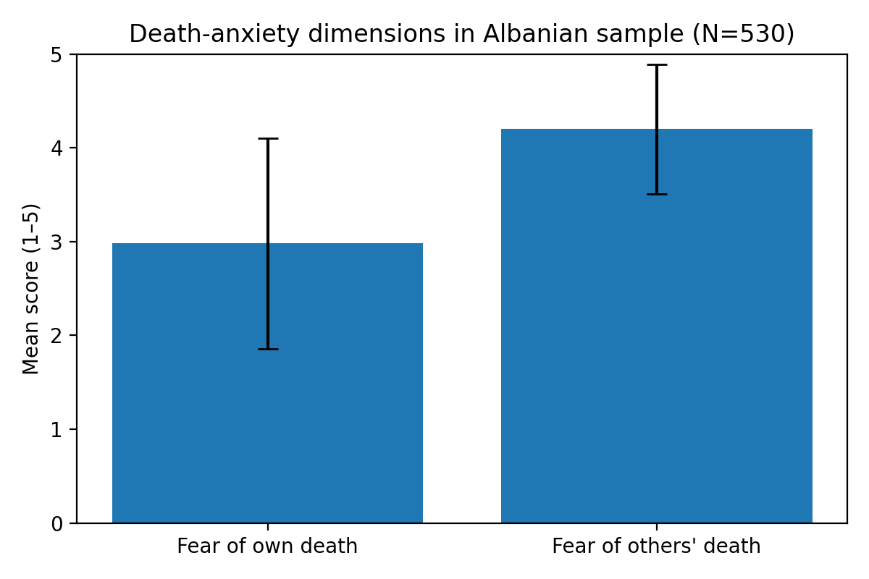
Figure 1: Mean levels of fear of own death vs fear of others’ death (error bars = SD).

3.2 Trait associations with death anxiety
Table 2 presents effect-size estimates for key trait–death anxiety associations, including 95% confidence intervals and BIC-based Bayes factor approximations. As hypothesized, Neuroticism showed a small positive association with fear of one’s own death (r = .17). Agreeableness showed a small positive association with fear of others’ death (r = .13). Other tested correlations were small and non-significant; in equivalence testing, Conscientiousness and Openness (for fear of own death) were compatible with negligible effects (|r| < .10).
Trait | Outcome | r | 95% CI | p | BF10 (approx)
Neuroticism | Fear of own death | 0.174 | [0.09, 0.26] | <.001 | 150.00
Agreeableness | Fear of others' death | 0.131 | [0.05, 0.21] | 0.003 | 4.27
Extraversion | Fear of own death | -0.030 | [-0.11, 0.06] | 0.491 | 0.06
Extraversion | Fear of others' death | 0.068 | [-0.02, 0.15] | 0.118 | 0.15
Openness | Fear of own death | -0.024 | [-0.11, 0.06] | 0.581 | 0.05
Conscientiousness | Fear of own death | -0.007 | [-0.09, 0.08] | 0.872 | 0.04
Table 2: Key correlations with confidence intervals and BIC-based Bayes factor approximations (Wagenmakers, 2007).

Religious affiliation
A one-way ANOVA tested differences in death anxiety across categories of religious affiliation. No significant differences emerged for fear of one’s own death, F(3, 525) = 1.89, p = .13, or for fear of others’ death, F(3, 525) = 1.14, p = .33.

Discussion
This study aimed to evaluate the cross-cultural robustness of trait correlates of death anxiety and to test whether associations differ by mortality dimension in an Albanian community sample. Two main findings stood out: (a) Neuroticism aligned with fear of one’s own death, and (b) Agreeableness aligned with fear of others’ death. Both effects were small in magnitude but statistically reliable and survived conservative multiplicity control, consistent with the view that trait–mortality links are present yet modest.
The pattern is theoretically coherent. Neuroticism reflects chronic negative affectivity and low tolerance of uncertainty, which plausibly intensifies self-focused mortality fears and anticipatory threat monitoring (Iverach et al., 2014; Watson & Clark, 1984). In contrast, the Agreeableness association was specific to fear of others’ death, suggesting that empathic attunement and relational investment can amplify anticipatory grief and distress about separation, even when they are adaptive in most interpersonal contexts (Mikulincer & Shaver, 2008; Stroebe & Schut, 2001).
A striking descriptive feature was the pronounced gap between fear of others’ death and fear of one’s own death. While cross-study comparisons should be made cautiously, this “relational skew” is consistent with a cultural ecology in which family bonds and social interdependence carry high psychological weight. In such settings, the most psychologically potent mortality cue may not be personal extinction but relational rupture: the imagined absence of the people who hold daily life together.
From a methodological standpoint, the present work responds directly to a common critique of incremental trait research: significance without interpretability. By emphasizing confidence intervals, multiplicity control, and equivalence testing, we show that several hypothesized links were not merely “non-significant” but compatible with effects too small to matter practically under a prespecified threshold. This is useful for theory pruning and for avoiding overfitting cultural narratives onto noise.
Clinically, the findings support a dimension-specific formulation. For individuals high in Neuroticism, interventions that target intolerance of uncertainty and catastrophic interpretation may be especially relevant when mortality cues are self-focused (Hayes et al., 2011). For highly agreeable individuals, work on emotion boundaries and differentiating compassion from over-identification may be more relevant when death anxiety is relational (i.e., oriented toward loss of others).
Limitations are substantial and should not be hidden behind confident verbs. The design is cross-sectional, preventing causal or directional inference. The sample was young and predominantly female, and recruitment was nonprobability-based. Future work should combine longitudinal designs with theoretically proximal mediators (e.g., attachment insecurity, meaning in life, intolerance of uncertainty) and, ideally, incorporate qualitative narratives of death to capture culturally specific meaning-making processes (Park, 2010; Steger et al., 2006).

Conclusion
In an Albanian community sample, Neuroticism related to fear of one’s own death and Agreeableness related to fear of others’ death, while other trait associations were small. Descriptively, participants reported substantially higher fear of others’ death than fear of their own death, highlighting the value of separating mortality dimensions in culturally embedded research. The findings are best understood as a replication-with-extension that maps boundary conditions and motivates longitudinal, mechanism-focused follow-up work.

Acknowledgment
The authors report no external funding and no acknowledgments.

References
- American Psychological Association. (2017). Ethical principles of psychologists and code of conduct. American Psychological Association.
- Becker, E. (1973). The denial of death. Free Press.
- Bogg, T., & Roberts, B. W. (2004). Conscientiousness and health-related behaviors: A meta-analysis. Psychological Bulletin, 130(6), 887–919. https://doi.org/10.1037/0033-2909.130.6.887
- Collett, L. J., & Lester, D. (1969). The fear of death and the fear of dying. The Journal of Psychology, 72(2), 179–181. https://doi.org/10.1080/00223980.1969.10543496
- Hayes, S. C., Strosahl, K. D., & Wilson, K. G. (2011). Acceptance and commitment therapy: The process and practice of mindful change. Guilford Press.
- Henrich, J., Heine, S. J., & Norenzayan, A. (2010). The weirdest people in the world? Behavioral and Brain Sciences, 33(2–3), 61–83. https://doi.org/10.1017/S0140525X0999152X
- Iverach, L., Menzies, R. G., & Menzies, R. E. (2014). Death anxiety and its role in psychopathology: Reviewing the status of a transdiagnostic construct. Clinical Psychology Review, 34(7), 580–593. https://doi.org/10.1016/j.cpr.2014.09.002
- Lakens, D., Scheel, A. M., & Isager, P. M. (2018). Equivalence testing for psychological research. Advances in Methods and Practices in Psychological Science, 1(2), 259–269. https://doi.org/10.1177/2515245918770963
- Lester, D. (2004). The factorial structure of the Revised Collett–Lester Fear of Death Scale. Death Studies, 28(8), 795–802. https://doi.org/10.1080/07481180490483472
- Lucas, R. E., & Diener, E. (2001). Understanding extraversion’s relation to positive affect: A within- and between-subjects analysis. Journal of Personality and Social Psychology, 81(3), 343–356. https://doi.org/10.1037/0022-3514.81.3.343
- Mikulincer, M., & Shaver, P. R. (2008). Attachment in adulthood: Structure, dynamics, and change. Guilford Press.
- Park, C. L. (2010). Making sense of the meaning literature: An integrative review of meaning-making and its effects on adjustment to stressful life events. Psychological Bulletin, 136(2), 257–301. https://doi.org/10.1037/a0018301
- Soto, C. J., & John, O. P. (2017). The next Big Five Inventory (BFI-2): Developing and assessing a hierarchical model with 15 facets to enhance bandwidth, fidelity, and predictive power. Journal of Personality and Social Psychology, 113(1), 117–143. https://doi.org/10.1037/pspp0000096
- Steger, M. F., Frazier, P., Oishi, S., & Kaler, M. (2006). The Meaning in Life Questionnaire: Assessing the presence of and search for meaning in life. Journal of Counseling Psychology, 53(1), 80–93. https://doi.org/10.1037/0022-0167.53.1.80
- Stroebe, M., & Schut, H. (2001). Meaning making in the dual process model of coping with bereavement. In R. A. Neimeyer (Ed.), Meaning reconstruction and the experience of loss (pp. 55–73). American Psychological Association. https://doi.org/10.1037/10467-003
- Wagenmakers, E.-J. (2007). A practical solution to the pervasive problems of p values. Psychonomic Bulletin & Review, 14(5), 779–804. https://doi.org/10.3758/BF03194105
- Watson, D., & Clark, L. A. (1984). Negative affectivity: The disposition to experience aversive emotional states. Psychological Bulletin, 96(3), 465–490. https://doi.org/10.1037/0033-2909.96.3.465
- World Medical Association. (2013). World Medical Association Declaration of Helsinki: Ethical principles for medical research involving human subjects. JAMA, 310(20), 2191–2194. https://doi.org/10.1001/jama.2013.281053
- Yalom, I. D. (1980). Existential psychotherapy. Basic Books.

