The Impact of Migration on Early Marriage in Punjab, Pakistan

Zartasha Kalsoom and Rabia Arif

ABSTRACT
Early marriages are a significant concern in developing countries, impacting society through limited economic opportunities, health complications, and increased vulnerability to domestic violence. This study examines whether the external migration of a household member reduces the likelihood of early marriage for female children in Punjab, Pakistan. Migration may alleviate economic pressures or exacerbate the problem, as indicated by the MICS dataset (2011, 2014 and 2018) for Punjab, Pakistan. We addressed the endogeneity of the migration decision approach by utilizing the instrumental variable approach. We use a triple interaction variable that comprise of historic migration rates, night time light intensity of the migrant destination countries and number of adult males in migrant sending households to generate an instrument highly correlated with the migration decision but uncorrelated with the female’s marriage decision directly. Overall, we find that migration has a significant impact on early marriage; however, their examination of subgroups have yielded mixed results.
Key Words: External Migration, Early Marriage, Caregiver, Instrumental Variable

Introduction
In this paper, we examine the impact of having an external migrant in a household on the marriage of females under eighteen in Punjab, Pakistan. Early marriage, also known as Child Marriage, is a deep-rooted social issue in many parts of the world, especially in developing countries. It is commonly associated with adverse outcomes, which include reduced educational attainment, creating limited economic opportunities, health complications, and increased vulnerability to domestic violence and poverty (Parsons J., et al., 2015). There are global efforts, such as policy interventions, socioeconomic factors, and cultural factors, that help delay marriage in rural and underprivileged regions. This study examines the impact of migration on early marriage in Punjab by analyzing data from the Multiple Indicator Cluster Surveys (MICS) of 2011, 2014, and 2018, employing an instrumental variable approach. We explore three domains: first, the overall effect of having a migrant in a household and measuring whether the probability of an under-18 female marrying a man in those households is significantly affected. Second, we divide our data by individual level and demographic characteristics to see if the overall results are masked by any of these observed differences among the subgroups. Third, we conduct a household analysis to mitigate further any impact that missing females, which can be due to leaving households for education and marriage, in a household can have on estimates to ensure whether the effect remains the same or not and see if there is any systematic difference that can cause estimate errors between migrant and non-migrant household.

A. Global and local context of early marriage
More than 650 million women alive today, according to the United Nations Children’s Fund, were married before their 18th birthday (UNICEF, 2018). Despite looking at Pakistan, legal frameworks such as the Child Marriage Restraint Act of 1929, which sets the legal marriage age at 18 for boys and 16 for girls, child marriage remains a dominant practice. Cultural traditions, socio-economic pressures, and limited access to education have contributed to the prevalence of early marriage, particularly in rural areas where traditional norms often dictate family decisions. A 64-year-old male is reported to have said that adolescent unmarried daughters are a burden, not because of the resources, but because they have to take care of their honor. (Albena Sotirova, 2020).

Early marriage occurs for various reasons, including family income, parental education, location, and cultural traditions (Quentin Wodon, 2017). In rural areas, families often marry off their daughters at a young age because they struggle financially, especially with the high cost of dowries. Some also believe early marriage keeps girls safe from social risks. In contrast, early marriage is less common in cities, where education and job opportunities are more accessible. These differences underscore the importance of understanding how migration—both within and outside a country—impacts early marriage, as well as other social and economic factors. Studies have consistently shown that wealthier families are less likely to marry off their daughters at a young age, as they have more resources to invest in education and can delay marriage without incurring economic repercussions (UNICEF, 2021). On the other hand, poorer families may view early marriage as a means to alleviate the economic burden on the household or as a source of financial security through a dowry (Lloyd, 2008; BER, 2018).

A mother’s education also makes a significant difference; we see that educated mothers are more likely to delay their daughters’ marriages, as they prioritize education and career opportunities. Research suggests that girls with educated mothers are significantly less likely to marry before turning 18, as their mothers are better equipped to challenge social pressures and advocate for their daughters’ rights (Ambrus, 2008). In contrast, mothers with little or no education may feel powerless to push back against traditional expectations that encourage early marriage
Other factors, such as health, location, and crime rates, also influence trends related to early marriage. In rural areas with limited healthcare, families may view marriage as a means to provide security for their daughters. High maternal health risks may also lead parents to believe that marrying their daughters early will protect them from complications later in life. Early marriage is more common in rural communities due to limited access to education, healthcare, and jobs. In places where female chastity is highly valued, some parents may rush into marriage arrangements to avoid social judgment or harassment (Sarkar, 2024).

B. Migration and early marriage
Migration in Pakistan is driven by both internal and international factors due to the country's socio-economic landscape. Internal migration, from rural to urban areas, has increased significantly over the past few years, driven by urbanization and the pursuit of economic opportunities. Whereas international migration, the focus of this study, has shaped family dynamics through remittances from abroad, especially from the Middle East. These remittances play a crucial role in household economies; hence, migration can have a complex effect on early marriage.

Migration can provide economic security, enabling families to delay marriage by investing in education and other opportunities. Remittances from international migration are often used to support daughters’ education, thereby delaying early marriage. On the other hand, migration can also intensify financial and social pressures, for example, in cases where fathers or male breadwinners migrate. The absence of a male guardian may lead to an increased risk of early marriage for girls, as families may feel pressure to secure their daughters’ futures through marriage (Nasrin, 2012).

Migration can affect early marriage differently depending on location, gender, wealth, health, and maternal education. It can be seen that migration tends to delay early marriage in urban areas, where access to education and healthcare is more widespread. In contrast, in rural areas, migration can increase the likelihood of early marriage due to economic and social pressures. Furthermore, gender dynamics also play a critical role; migration often leads to different expectations for boys and girls regarding marriage, education, and employment (Ghimire, 2013).

C. Theoretical framework and research gaps
Although there is extensive literature on early marriage and its determinants, few studies have examined the causal impact of migration on early marriage using techniques such as instrumental variables. Many previous studies have employed logistic regression models to investigate the impact of socio-demographic factors on early marriage (Nasrin, 2012; Saleheen, 2021), but these papers overlook the complex relationship between early marriage and migration.

This study aims to fill this gap by using an econometric technique of instrumental variables to analyze the impact of migration on early marriage in Punjab, Pakistan. Using the Punjab MICS data from 2011, 2014, and 2018, this research will provide a comprehensive analysis of how migration interacts with household characteristics, maternal education, wealth, health, and location to influence early marriage outcomes.

Instrumental variable analysis helps account for endogeneity while establishing a clearer causal relationship between migration and early marriage, a crucial step in designing effective policy interventions. The instrumental variable is not only strongly correlated with an individual's decision to migrate, but it also varies at the household level, allowing us to obtain more accurate results and ensuring that it is not correlated with our dependent variable, namely, early marriage.

Additionally, we divide our data by individual level and demographic characteristics to see if the overall results are masked by any of these observed differences among the subgroups. Third, we conduct a household analysis to mitigate any further impact that missing females, who may have left households for education or marriage, can have on estimates, ensuring whether the impact remains the same or not.

D. Research question
The impact of the migration of a household member, who is a potential caregiver of the recipient household, on early marriage outcomes in Pakistan. How does the migration influence the likelihood of early marriage in Punjab, Pakistan? What is the causal effect of migration on early marriage when analyzed using instrumental variable techniques, based on the MICS datasets from 2011 to 2018?

E. Research objectives
- To analyze the impact of caregiver migration of the recipient household on the marriage status of females under age eighteen.
- To correct for endogeneity in migration decisions by using a new instrumental variable approach that accounts for historical migration rates, nighttime light intensity data, and the number of adults in a household.
- To explore the heterogeneity of the migration impact by household head sex, educational level of the head, location (urban vs. rural), wealth, and female education.
- To examine how migration influences early marriage outcomes, specifically by analyzing the proportion of unmarried females under 18 to the total number of females under 18, while considering the moderating roles of household resources, cultural norms, and economic disparities.

This study is structured into six sections. Section 1 introduces the research problem, objectives, and significance of the study. Section 2 provides a comprehensive review of the relevant literature, offering insights into the theoretical and empirical foundations of the research. In Section 3, we outline the methodology, including data sources, variable descriptions, and analytical techniques employed in the study. Section 4 presents our empirical findings, analyzing the results in detail and discussing their implications. Finally, Section 5 concludes the study by summarizing the key findings, drawing conclusions, and suggesting directions for future research.

II. LITERATURE REVIEW

Impact of migration on early marriage: current findings
Existing research presents diverse perspectives on the impact of migration on early marriage. Some studies argue that migration makes early marriage more common, especially in rural and economically struggling communities. When families migrate for work, their traditional structures can break down, leading them to see early marriage as a way to ensure financial stability and social security (Petroni, 2017). The added economic and social pressures caused by migration often push families to marry off their daughters in hopes of receiving financial support from their husbands' families. Moreover, long-term studies indicate that household instability resulting from migration tends to affect adolescent girls the most, leading to early marriage as a strategy for securing both economic and social protection (Kumar & Singh, 2023).
However, an alternative perspective argues that migration can serve as a transformative force in delaying early marriage. The migration of young females can expose them to diverse socio-cultural norms and new ideologies, which may challenge and redefine traditional expectations upon their return to their home communities (Engebretsen, 2020; Antu, 2022). Similarly, empirical studies indicate that migration often disrupts traditional marriage practices, particularly in contexts where modernization and increased access to education influence marital decision-making. Migrant girls, particularly those who move for educational and employment opportunities, often require enhanced life skills, education, and healthcare before migration, which may contribute to a delay in marriage (Temin, 2013). A comparative study by Riaz (2022) found that exposure to modernized societies through migration has significantly altered traditional marital norms, leading to an increase in the average age of marriage. Furthermore, evidence from South Asia suggests that migration-related access to digital technology and higher educational attainment delay marriage among migrant-sending households, as economic aspirations shift towards human capital investment rather than early marital arrangements (Das & Mukherjee, 2023).

On the other hand, migration in the form of displacement and forced migration can reinforce early marriage practices. Displacement often increases vulnerability among women and children, which helps to increase the likelihood of getting married early or early marriage as a survival mechanism in precarious environments. For instance, research on Syrian refugee women has shown a preference for early marriage as a strategy to mitigate the economic and social hardships induced by forced migration (Chalmiers, 2021). Additionally, a cross-country analysis by Bharadwaj (2022) highlights that displacement-induced migration is strongly correlated with changes in marriage patterns, as families prioritize early marriage in response to security concerns and economic instability. Historical evidence from the 1947 Partition of India and Pakistan further supports this claim, as displaced young girls were found to have significantly higher rates of early marriage, lower educational attainment, and higher fertility rates (Lu, 2021). Recent studies also reveal that conflict-driven migration leads to gendered vulnerabilities wherein young girls are disproportionately affected due to heightened risks of poverty, lack of education, and reduced economic agency, contributing to early marriage (Hassan & Rahman, 2023).
Furthermore, recent studies reinforce the complexity of migration’s impact on early marriage. Research by Adhikari (2023) suggests that exposure to urban lifestyles and higher educational attainment related to migration can significantly delay the marriage age in South Asian contexts. Similarly, Bhatia and Ghosh (2023) emphasize the role of remittances in reducing economic pressures on migrant-sending households, thereby lowering the incentive for early marriage. In contrast, Rahman and Javed (2023) argue that in certain patriarchal societies, migration-induced economic instability can further entrench early marriage norms, particularly among low-income households that perceive marriage as a means of securing financial and social stability. Additionally, a recent study by Oliveira and Costa (2024) finds that migration outcomes vary by socioeconomic status, with middle-income migrant families exhibiting greater resilience against early marriage practices due to enhanced access to education and healthcare, while low-income migrant households remain vulnerable to economic constraints that sustain early marriage traditions.
Overall, the impact of migration on early marriage is multifaceted, shaped by economic, social, and cultural dynamics. While migration can serve as a mechanism for social transformation and delay early marriage through increased educational and economic opportunities, it can also reinforce early marriage norms in contexts characterized by economic insecurity, displacement, and patriarchal structures. Future research should adopt a nuanced approach that accounts for the intersectionality of migration, economic stability, and gender norms to provide comprehensive policy recommendations aimed at mitigating the risks of early marriage in migration-affected communities.

Empirical approaches
Various econometric techniques have been employed to analyze the impact of migration on early marriage. Some studies have examined historical displacement, particularly of women and children, leading to a significant increase in early marriages. These studies utilize the exogenous timing and arbitrary nature of migration events, often employing a difference-in-differences (DiD) design to establish causal relationships (Lu, 2021).

Other research explores the determinants of early marriage using an instrumental variable (IV) approach to address concerns about endogeneity arising from socio-economic and cultural factors that influence marriage decisions (Delprato, 2015). Additionally, qualitative research designs, such as the life-story approach, have been factored to investigate the cultural, economic, and psychological drivers driving early marriage (JE, 2024).

Sarkar (2024) employs a linear probability model to analyze the relationship between the likelihood of early marriage and crime rates against women in a given locality. Similarly, Krum (2024) investigates the interplay between early marriage, early pregnancy, adverse childhood experiences (ACEs), and intimate partner violence (IPV) using path analysis while accounting for sample design and within-country clustering.

Further studies contribute to this literature by employing various econometric methodologies. Rahman and Javed (2023) use propensity score matching (PSM) to estimate the causal effects of migration on early marriage outcomes. Bhatia and Ghosh (2023) employ structural equation modelling (SEM) to investigate the long-term socioeconomic implications of early marriage in migrant households. Adhikari (2023) employs a fixed-effects panel regression approach to examine how migration patterns affect shifts in marriage norms over time. Additionally, Bharadwaj (2022) conducts a cross-country analysis using hierarchical modeling to examine the macroeconomic and policy-related determinants of early marriage. These methodological advancements contribute to a more comprehensive understanding of the relationship between migration and early marriage.

Our empirical approach
This study looks into the impact of caregiver of recipient household’s migration on the marriage status of females under 18 while correcting for endogeneity in migration decisions by using a instrumental variable approach (which is already established by (Arif, Chaudhry, & Chaudhry, 2023)) that accounts for historical migration rates, nighttime light intensity data and number of adults in a household. Additionally, the study examines the heterogeneity of migration impacts by household head sex, educational level of the head, location (urban vs. rural), wealth, and female education.

Our study provides a more sophisticated and in-depth analysis of the impact of external migration on the likelihood of early marriage in migrant households located in Punjab, Pakistan, by addressing the problems of endogenous migration decisions and omitted variable bias, while also considering key independent variables to yield efficient estimates both by exploring an overall effect as well as exploring heterogeneity in the subgroups and identifying how migration affect early marriage differently.

III. METHODOLOGY
This section discusses the multiple sources used in this study and the methodology employed to estimate the causal relationship between the migration of the recipient household’s caregiver and the likelihood of early marriage.

Data
We use the Multiple Indicator Cluster Survey (MICS) data collected for Punjab, Pakistan, in 2011, 2014, and 2018. Punjab is the largest province of Pakistan, which is why it is broadly representative at the national level, with nearly 60% of Pakistan's total population residing there. The data collected by MICS consists of more than 1,900,000 individuals from households across 35 districts of Punjab. It collects data on women, including their ages, whether they are currently married, or not, and the information about the households they live in, whether there is an individual who has migrated from that household or not.

We use two additional datasets to construct our instrumental variable, which has been used to correct for the endogenous decision to migrate within a household: the Pakistan Bureau of Emigration and Overseas Employment (BEOE) and the National Centre for Economic Activity (NCEA). BEOE is used to construct historic migration rates at the district level, survey according to the years. NCEA is used to provide information on the nighttime light intensity data that have been used to construct measures for economic activity , the three-central emigrant destination countries for Pakistan for each survey for the respective years.

Our strategy
This study estimates the impact of a migrant in the recipient household on the probability of early marriage in Punjab, Pakistan. We select only females who are under the age of 18 to determine whether the migration of a household member affects their chances of getting married before the age of 18.
Following equation, which shows the impact of migration on female f in household h, district g, for survey year t:
- ${EM}_{fhgt}= α_{0}+α_{1}M_{ght}+α_{2}{Individual Controls}_{sf}+α_{3}{HH Controls}_{sh}+α_{4 }{District Dummies}_{g}+α_{5}{Time Dummies}_{t}+η_{ght}+μ_{fght}$,
- E($μ_{fght}$)=0 and E ($M_{ght}$, $η_{ght}$) ≠ 0

where ${EM}_{fhgt}$ Is a dependent variable that takes a value of 1 if the female of household h in district g gets married before the age of 18 for survey year t. The right-hand side variable that examines the impact of a migrating household member in the equation is $M_{ght }variable$, which takes a value of 1 if an individual has emigrated from the recipient household.

Control variables— We include household characteristics, female chararacteristics, district, and time dummies as our control variables. Household characteristics include the sex of the household head, which takes a value of 1 if the household is headed by a male and 0 if it is headed by a female. Household head education is divided into 5 parts: a household head with no education takes a value of 0, a household head with primary education takes a value of 1, a household head with middle-level education takes a value of 2, a household head with a secondary educational level takes a value of 3, and a household head with higher education, which takes a value of 4.
We also use a dummy=1 that consider whether or not consider whether the household head owns a television or not; if the household owns a television, it takes a value of 1, otherwise zero. We also consider economic status household, which is divided into 5 categories. We consider whether the household is located in an urban or rural area; the variable takes a value of 1 if it is located in an urban area and zero if it is in a rural area.

Individual-Level characteristics comprise of the educational level of females, which is divided into five parts: females without any education take a value of 0, females with primary education = 1, females with middle-level education = 2, females with secondary educational level = 3, and higher education takes a value of 4. We added the square of female education, which is also divided into five parts. Females’ without any of education level = 2, females with secondary educational level = 3, and higher education takes a value of 4. A female’s age is also added as an independent variable in the individual characteristics.

Individuals living in rural areas are more likely to marry under the age of 18 and migrate to earn simultaneously. Hence, we use an already established instrumental variable for our key explanatory variable, migrant.

To correct for the bias caused by the endogeneous migration decision, we employ an instrumental variable (IV) approach already established in literature by Arif, Chaudhry, & Chaudhry, 2023. They , using the product of historic migration rates along with nighttime light intensity and the number of males in a household to construct a strong IV for migrant individuals in a household.
- $Ζ_{hgt}=\sum_{h=1}^{n}{Μ_{gt-5}L_{gt}Α_{h }}$

$Μ_{gt-5}$ estimates the historic migration rate for district g, which comprises the total number of people that have migrated from 1980 until at least five years prior to the survey year. $L_{gt}$is the sum of weighted average deviations of nighttime light intensity data from it detrended means. We have calculated this data from BEOE and selected top three migrant-receiving countries for Pakistan, that are Oman, Saudi Arabia and U.A.E. Lastly, $Α_{h }$includes the number of male adults in a household.

Each component of our instrument has strong theoretical and empirical support in migration literature. Prior research shows that past migration influences future migration by strengthening social networks between origin and destination regions (Acosta, 2006; Arif & Chaudhry, 2015; Hanson & Woodruff, 2003; Mansuri, 2006a, b; Woodruff & Zenteno, 2007). These networks reduce migration costs and provide social support, making migration more accessible. Nighttime lights are widely used as a proxy for economic activity (Henderson et al., 2003). Positive deviations from the long-term trend indicate periods of economic expansion, which in turn signal greater demand for migrant labour, acting as a pull factor for migration. The presence of more adult males suggests a larger available labour supply at home, potentially easing migration decisions by ensuring household stability and security in the migrant’s absence (Mansuri, 2006a, b).

By interacting with these three factors, our instrument captures both household-level and district-level variation in migration probability. Periods of above-average economic activity in major destination countries, combined with strong historical migration networks and a higher number of adult males in a household, increase the likelihood of migration.

Our instrument is strongly correlated with migration decisions. This follows from the extensive literature demonstrating that past migration influences migration choices. It also varies at the household level, which enables the obtaining of accurate results. Positive deviations from the mean indicate that economic activity in the top three migrant-receiving countries is above average in terms of nighttime light intensity, signaling better job opportunities. A household with more male adults is likely to have a higher probability of migrating abroad.

The instrumental variable is not correlated with our dependent variable, that is, early marriage. (Mansuri, 2006) Moreover, Chaudhry (2015) has used historic migration and the number of male adults as exogenous instruments for migration. Arguing that due to Pakistan’s narrow export base and manufacturing base, it is difficult to imagine how host country business cycles, measured as deviations in trends of nighttime light intensity, would affect the likelihood of girls getting married before the age of 18. Given Pakistan’s limited manufacturing and export base, it is unlikely that fluctuations in host country economic activity—measured through nighttime light deviations—will affect early marriage, except through their impact on migration. This supports the validity of our instrument in addressing endogeneity concerns and ensuring unbiased estimates of the effects of migration.

IV. EMPIRICAL WORK
This section presents the inferential and descriptive statistics, as well as the empirical strategy employed in our estimates.

Inferential and descriptive statistics
The number of young females aged 18 years or younger in MICS 2011, 2014, and 2018 is 33,892. It accounts for approximately 12.16% of the total 244,750 females. Table 1 shows the descriptive statistics of key variables between migrant households and non-migrant households, along with the significance of the differences in their means.

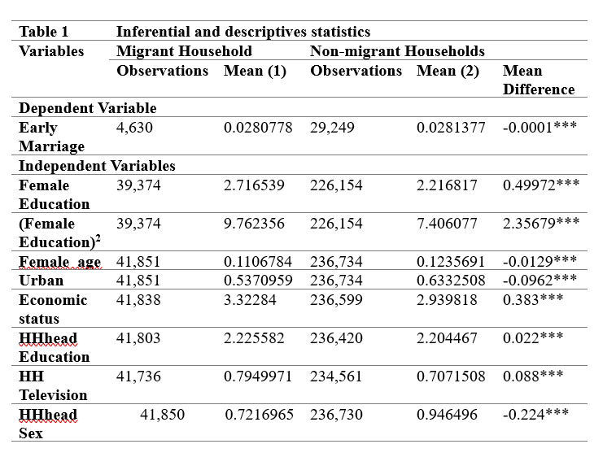
Our dependent variable, Early Marriage, is slightly higher in non-migrant households, with a mean of 0.0281, compared to migrant households, with a mean of 0.0281. The difference (-0.0001) is small but statistically significant. This suggests that while the prevalence of early marriage is nearly identical between migrant and non-migrant households, the slight difference could reflect structural or cultural factors influenced by migration.

Our independent variables, particularly female age and education level, play a significant role in our research. They provide an insight into the demographic and socioeconomic factors influencing the decisions. For instance, the slightly younger average age of females in migrant households could be due to differences in household composition or migration-related factors that affect the demographic structure. The higher education level of females in migrant households could be attributed to better educational opportunities in migration destinations or a prioritization of education in migrant households. These variables also reflect socioeconomic differences between migrant and non-migrant households.

Then, female education squared shows that since squaring education magnifies larger values, this result indicates that the gap in female education between the two groups widens as the level of education increases. Females in migrant households are more likely to achieve higher levels of education (e.g., secondary or tertiary) compared to their counterparts in non-migrant households.

Urban indicates whether the household resides in an urban area. Migrant households are significantly less likely to reside in urban areas (-0.0962***). This suggests that migration in this context is predominantly from rural to urban areas, where urban areas often host non-migrant families with better facilities.

Economic status refers to a household's economic position. Migrant households have a significantly better economic status (0.383***). Migration often leads to better income opportunities, resulting in economic improvement for migrant families. Household head education measures the education level of the household head. Migrant households have slightly higher household head education levels (0.022***). Migration may be correlated with more educated individuals seeking better opportunities.

HH Television indicates whether the household owns a television. Migrant households are significantly more likely to own a television, likely reflecting improved economic conditions and access to technology in these households. HH head sex indicates the sex of the household head, with a lower proportion of males in migrant households. Migrant households have a significantly lower proportion of male-headed households, with a coefficient of -0.224***. This could suggest that migration often involves male members moving for work, leaving women as the primary household heads in their absence.

The significant t-tests across all variables suggest that the observed mean differences are unlikely due to random chance. These results highlight systematic differences between migrant and non-migrant households, providing valuable insights into migration-driven changes in socioeconomic, educational, and demographic factors. Migration has a positive influence on economic status and access to resources, while also reducing the likelihood of urban residence. Female education, although slightly higher in migrant households, may reflect access to better opportunities, but further analysis is needed to understand its influence on early marriage. The reduced proportion of male-headed households in migrant families is consistent with migration patterns where males often relocate for work.

Impact of IV on the decision to migrate
This section examines the impact of potential caregivers on the likelihood of young females in Punjab, Pakistan, marrying before the age of 18. Table 2 shows the first-stage probit model for the dependent variable Migrant, which takes the value of 1 if the potential caregiver of the household has migrated.
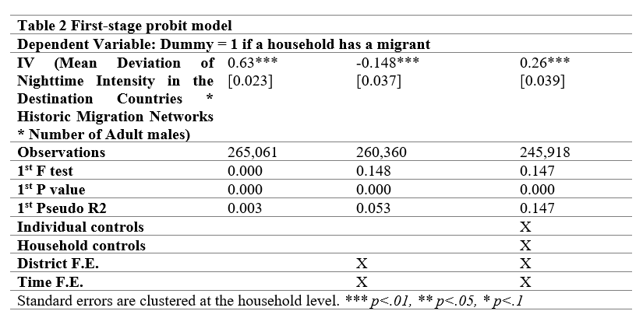
The independent variable is our Instrumental variable, which is the product of three variables: the mean deviation of nighttime intensity in the destination countries, historical migration rates, and the number of adult males. Column 1 presents the probit regression results for the specification that includes only the instrumental variable, without any controls. The coefficient is 0.63, statistically significant at the 1% level, suggesting that the IV variable significantly increases the probability of a potential caregiver migrating, with a standard error of 0.023. Column 2 presents the regression results for the specification with the instrumental variable, along with district and time controls. The coefficients, -0.148, turn out to be significant at the 1% level with a precise standard error of 0.037 and 260,360 observations.

Column 3 presents the probit regression results for instrumental variables, controlling for district, time, individual, and household characteristics. The coefficient is 0.26 and statistically significant, with a standard error of 0.039 and 245,918 observations. This implies that a one-standard-deviation increase in the instrument variable increases the probability of a household member migrating by 26 percentage points. Hence, the estimates show that IV is a strong predictor of migration at the household level, as evidenced by the consistently significant coefficients and high F-statistics.

The Pseudo R-squared value increases as more controls are added, indicating that the model’s explanatory power improves significantly when additional covariates are included. The fixed effects, introduced in the second and third columns for district and time, demonstrate that including these controls yields a more robust estimate by addressing district-level heterogeneity and time-varying factors, such as policy changes or economic conditions, that influence migration.

Overall, coefficients across all models are highly significant, indicating a strong relationship between the instrumental variable and the probability of caregiver migration. Strong historical migration networks and economic opportunities (proxied by nighttime light intensity) are key determinants of caregiver migration.

Next, in Table 3, we present the second-stage results, measuring the impact of a household having a migrant on the probability of females in Punjab, Pakistan, getting married before the age of 18.

The dependent variable is the dummy variable for early marriage, which takes the value of 1 if the female is married before the age of 18 and 0 otherwise. We exclude all females who are 18 years of age and older. Our explanatory variable here is the residual results obtained after running the first-stage probit regressions. The coefficients in Table 3 are insignificant, as indicated by their high p-values. Column 1 presents the results without controls; Column 2 includes district fixed effects and time fixed effects. Column 3 presents the results for the second-stage probit model, which includes individual controls, household controls, district fixed effects, and time fixed effects.

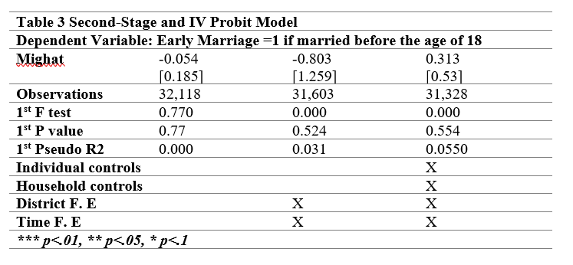
Overall, our findings indicate that the explanatory variable does not have a statistically significant effect on the likelihood of marrying before the age of 18 among young females in Punjab, Pakistan.

Heterogeneous effects
Next, we explore some of the potential heterogeneous effects within different subgroups of Punjab, Pakistan. We divide our sample into subgroups based on the rural/urban divide, rich versus poor, whether a female is educated or not, whether the household head is educated or not, and whether a male or female heads the household to see if the overall results are masked by underlying heterogeneity present in the sample.
The impact of external migration on early marriage by wealth is examined in Table 4, which presents the results of a probit regression with and without our instrumental variable. The analysis estimates the effect of external migration on early marriage, focusing on two wealth groups. One is the rich, which consists of the top three wealth quintiles, and the poor, which represents the lower two wealth quintiles of our data. The dependent variable is a dummy variable that takes a value of 1 if the females get married before the age of 18. In contrast, the explanatory variable takes a value of 1 if the recipient household’s caregiver has migrated.

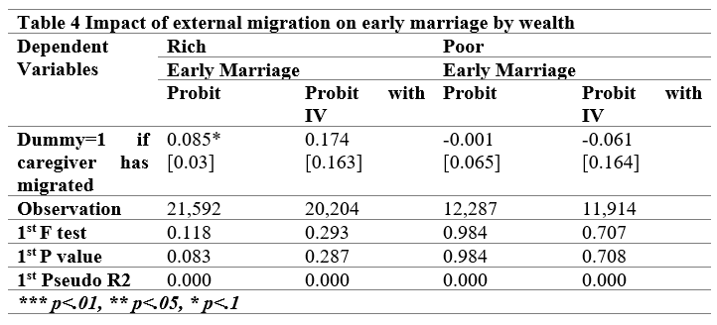

The first column in each group estimates the effect of migration on early marriage using a standard probit model. Column 2 in each group employs an instrumental variable approach to address potential endogeneity in the migration variable. The analysis does not provide strong evidence of a significant impact of migration on early marriage, either for the rich or the poor groups. Despite some positive coefficients for the rich group, the results are generally weak and not robust across different model specifications.

Impact of external migration on early marriage by rural-urban divide—Table 5 presents the impact of external migration on early marriage in Punjab, Pakistan, across both urban and rural settings.
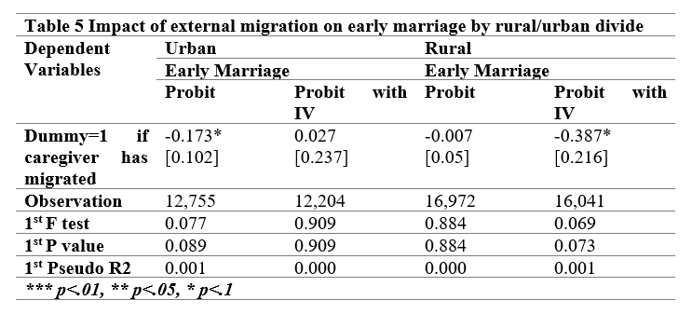
For urban areas, column 1 presents the simple probit and the coefficient for the dummy variable, indicating that the likelihood of getting married decreases by 17.3% if the caregiver migrates, with a marginally significant result. However, when IV is introduced, the relationship is positive and statistically insignificant. For rural areas, migration with or without IV has a negative impact on early marriage, and when we introduce IV, our result is marginally significant. This could mean that having a migrant in a household that is located in rural areas can change the social norms and expectations, hence delaying early marriage for girls under 18 in Punjab, Pakistan.

Another potential explanation is that more women in rural areas are getting married at an early age, so due to migration, we can see a more pronounced effect on their decision not to get married.

Impact of external migration on early marriage by female education—Table 6 displays the impact of external migration on early marriage, focusing on the difference between uneducated females and those who have received education.

The results for females with at least some level of education suggest that migration does not have a significant impact on early marriage, as indicated by probit regression. When the IV approach is introduced, the results are marginally significant, indicating that the migration of the caregiver has a positive effect on the likelihood of early marriage for females under 18 who have some level of education.
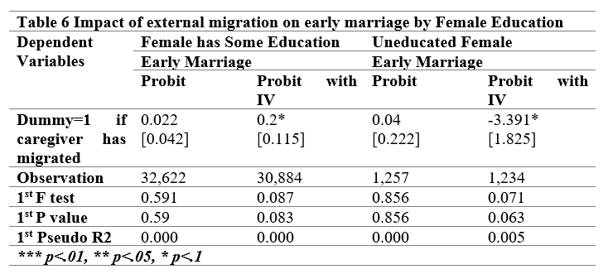
Households with migrant members may prioritize finding educated brides for their sons, as increased income and improved living standards may lead them to seek partners who can contribute to the family's social and economic advancement in comparison to uneducated females, whose coefficient decreases if there is a migrant in the recipient household.

We know that females with no or minimal education are significantly more likely to marry before the age of 18 compared to those with primary education. Hence, due to migration, we can observe a more significant impact on the lives of uneducated females, particularly in terms of early marriage.

Impact of external migration on early marriage by household head sex— Table 7 examines the impact of external migration by focusing on the difference between households headed by males and females, employing a probit model with and without an instrumental variable approach.
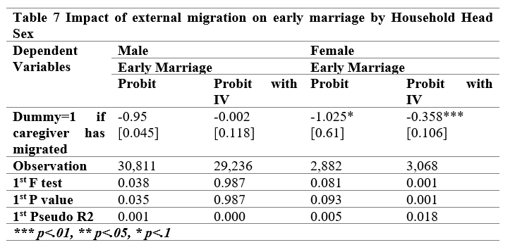
The results for households headed by males suggest a negative relationship between caregivers (in the husband’s family) being migrated and the probability of getting married before the age of 18, although this relationship is not statistically significant. When examining the results for female-headed households, the data suggest a significant negative relationship between caregiver migration and early marriage for households headed by males, as determined by the Probit model. The last column of the table examines the probit model with the IV approach, revealing a strong and significant relationship between caregiver migration and the likelihood of marrying before the age of 18. Households headed by females may prefer to marry their sons to women with a higher level of education, which could reflect their increased socioeconomic status and aspirations for the next generation.

Impact of external migration on early marriage by household head education—Table 8 presents the impact of external migration on early marriage, examining household head education using both the simple probit model and the probit model with the IV approach.

The results suggest that the probit model with the IV approach yields significant results for both groups, whereas the simple probit model proves to be insignificant. For households headed by individuals with no education, there is a positive and marginally significant result. In households with uneducated heads, the option of early marriage may be seen as a strategy to capitalize on the increased remittance income and believe that younger brides are more likely to conform to traditional sex roles and contribute to the household.
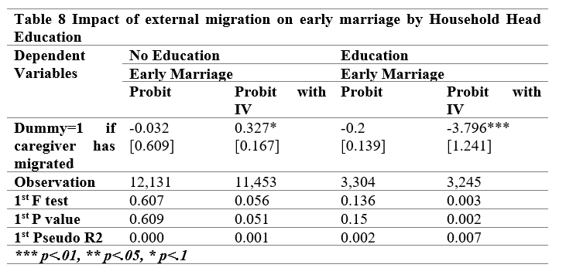
On the other hand, if the household head has an education, the results suggest a strong negative relationship between household caregiver migration and early marriage. Since the head has some level of education, they might prefer older brides (18 and above) who are more experienced and capable of managing household responsibilities. Additionally, these households might also seek brides with some education to ensure compatibility and intellectual stimulation within the family.

We recognize a significant association between the education level of the household head and the outcomes of early marriage. Due to migration, we can see a more pronounced effect on their decision not to take in a young daughter-in-law.

Robustness test
This section presents the findings from IV analysis for the year 2018, where we change our dependent variable to the proportion of married females under 18 to the total number of females under 18. There are two stages to check for robustness: the first stage examines the relationship between the IV and migration, which is the endogenous explanatory variable. The second stage estimates the causal effect of migration on the proportion of married females under 18 years old.

First stage results— We will first check the correlation between our IV, derived from the product of three terms as discussed above, and whether the household has any migrants or not. Table 9 presents the first-stage results for the year 2018.
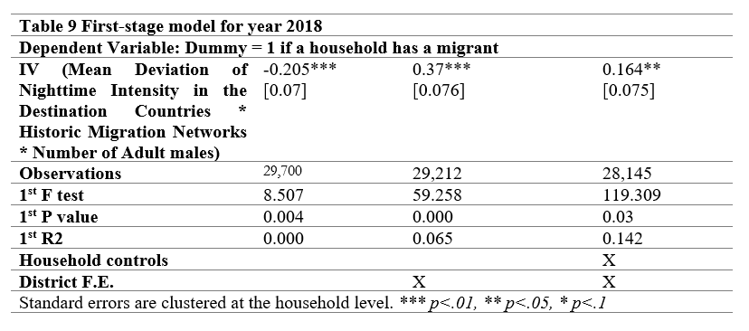
Column 1 of the table shows that the coefficient for the instrument is -0.205, which is statistically significant. This indicates that higher values of the instrument are associated with a reduced likelihood of migration. Column 2 shows that the coefficient is 0.37***, which is significant at the 1% level, suggesting a positive relationship between the instrument and migration when district fixed effects are included. The last column, 3, has the coefficient for the instrument of 0.164**, which is significant at the 5% level, indicating a weaker but still positive association. Hence, the first-stage results confirm the instrument's relevance in predicting migration across all specifications. However, the weak F-statistic in Column 3 highlights the need for caution in interpreting second-stage results based on this specification.

Second-stage results—The second-stage IV regression examines the causal effect of migration on the proportion of married females under 18 in a household. Table 10 presents the second-stage results for 2018.
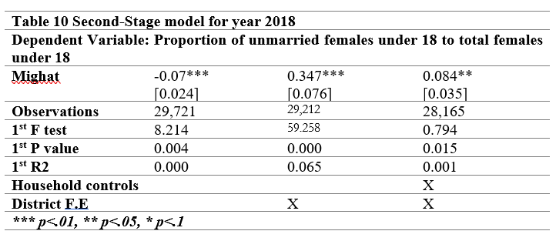
Column 1 of Table 10 shows that migration reduces the proportion of unmarried females under 18 by 0.07***, which is statistically significant at the 1% level. This result suggests that households with migrant caregivers are less likely to marry off females under 18, potentially due to improved economic conditions or shifting social norms.

Second, the effect of migration becomes positive with a coefficient of 0.347***. This suggests that in specific contexts, migration may increase the proportion of unmarried females under 18, possibly due to improved economic opportunities or other household dynamics. In the last column, when we add the household controls and 35 district dummies for Punjab, Pakistan, migration has a positive effect of 0.084**. The result is statistically significant at the 5% level, indicating a minor but still positive impact. F-statistics for the first-stage regression remain high in Columns 1 and 2, 8.214 and 59.258, respectively, confirming the robustness of the instrument. However, the low F-statistic in Column 3, 0.794, suggests weak instrument bias in this specification.

Our results suggest that migration may reduce early marriage by improving economic resources and educational opportunities, as shown in Column 1. Alternatively, migration may exacerbate early marriage in specific contexts, potentially due to weakened household supervision or persistent cultural norms, as indicated in Columns 2 and 3.

V. CONCLUSION
Literature discusses how migration can expose girls to new ideas that may differ from cultural expectations for them once they return to their home communities, potentially having a positive impact on delaying marriage. (Engebretsen, 2020), (Antu, 2022). On the other hand, migration exacerbates child marriage in rural areas, where economic migration creates a vacuum in traditional family structures, pushing families to marry off young girls as a means of economic survival or protection (Petroni, 2017). However, there are very few articles that discuss the external migration of an individual, also the potential caregiver, of the recipient household, and its impact on the likelihood of marrying a female under 18 years of age.

This study examines the impact of the external migration of a potential caregiver in the recipient household on the likelihood of getting married for females under the age of 18 in Punjab, Pakistan. We employed an instrumental variable approach, as established and utilized by Arif, Chaudhry, and Chaudhry (2023), Chaudhry (2015), and Mansuri (2006), using data from MICS Punjab for 2011, 2014, and 2018.

Additionally, we used a robust econometric framework to control for endogeneity. Overall, our results suggest that migration has no significant impact on early marriage; however, subgroup analyses reveal variations in this effect. Having a migrant person in a household that is located in rural areas can change the social norms and expectations, hence delaying early marriage for girls under 18 in Punjab, Pakistan. It may also prioritize finding educated brides for their sons.

Households headed by females may prefer to marry their sons to women with higher levels of education, which could reflect their increased socioeconomic status and aspirations for the next generation. Additionally, educated household heads might prefer older brides (18 and above) who are more experienced and capable of managing household responsibilities.

Robustness results support the hypothesis that migration delays early marriage by increasing household resources and promoting modern values. Nevertheless, when we add district dummies with household controls, we obtain positive results, suggesting that contextual factors, such as cultural norms and economic disparities, may counteract the beneficial effects of migration.

REFERENCES
Albena Sotirova, K. v. (2020, May 29). Ready to marry? Exploring the dynamics of child marriage in Pakistan. Retrieved from Girls not Brides: https://www.girlsnotbrides.org/articles/ready-to-marry-dynamics-of-child-marriage-in-pakistan-evidence-from-three-development-programmes/
Ambrus, E. F. (2008). Early Marriage, Age of Menarche, and Female Schooling Attainment in Bangladesh. Journal of Political Economy, 881–930.
Antu, J. F. (2022). The Effect of Rural-Urban Migration on the Age at Marriage Among Adolescent Girls in Bangladesh. Frontiers in Public Health.
Arif, R., Chaudhry, T. T., & Chaudhry, A. A. (2023). Emigration’s Heterogeneous Impact on Children’s Wellbeing in Punjab, Pakistan. Child Indicators Research.
BER. (2018). The economics of child marriage. Berkeley Economic Review.
Bharadwaj, P. (2022, May 09). The impact of displacement on women’s marriage outcomes: Evidence from the partition of India. Retrieved from IDEAS FOR INDIA: https://www.ideasforindia.in/topics/miscellany/the-impact-of-displacement-on-women-s-marriage-outcomes-evidence-from-the-partition-of-india.html#
Chalmiers, R. A. (2021). Early marriage among Syrian refugees in Jordan: exploring contested meanings through ethnography. Sexual and Reproductive Health Matters, 287–302.
Chaudhry, R. A. (2015). The Effects of External Migration on Enrollments, Accumulated Schooling, and Dropouts in Punjab. Applied Economics, 1607–1632.
Engebretsen, S. (2020). Adolescent girls’ migration and its impact on early marriage: Qualitative findings in Mali. PLOS ONE.
Ghimire, D. A. W. (2013). Marital processes, arranged marriage, and contraception to limit fertility. Demography, 1663–86.
JE, N. J. (2024). Early marriage, education, and mental health: experiences of adolescent girls in Mozambique. Front. Glob. Womens Health.
Lloyd, C. B. (2008). Marriage and childbirth as factors in dropping out from school: An analysis of DHS data from sub-Saharan Africa. Population Studies, 1–13.
Lu, F. (2021). Marriage outcomes of displaced women. Journal of Development Economics.
Mansuri, G. (2006). Migration, school attainment, and child labor: evidence from rural Pakistan. World Bank Policy Research Working Paper.
Marcos Delprato, K. A.-F. (2015). On the impact of early marriage on schooling outcomes in Sub-Saharan Africa and South West Asia. International Journal of Educational Development, 42–55.
Miriam Temin, M. R. (2013). Girls on the Move: Adolescent Girls & Migration in the Developing World. New York: Population Council.
Nasrin, S. &. (2012). Factors Affecting Early Marriage and Early Conception among Women: A Case Study of Slum Areas in Rajshahi City, Bangladesh. International Journal of Sociology and Anthropology, 54-62.
Parsons, J. (2015). Economic Impacts of Child Marriage: A Review of the Literature. The Review of Faith & International Affairs, 12–22.
Petroni, S. (2017). New Findings on Child Marriage in Sub-Saharan Africa. Annals of Global Health, 781–790.
Quentin Wodon, C. M. (2017). Economic Impacts of Child Marriage: Global Synthesis Report. Washington, DC: ICRW.
Riaz, N. (2022). Modernization Effects on Marriage Practices and Family System in South Punjab. A Case Study of Tehsil Bhakkar. INTERNATIONAL JOURNAL OF INNOVATIVE RESEARCH IN MULTIDISCIPLINARY EDUCATION, 36–40.
Saleheen, A. A. (2021). Sociodemographic factors and early marriage among women in Bangladesh, Ghana, and Iraq: An illustration from the Multiple Indicator Cluster Survey. Heliyon.
Sarah Huber-Krum, S. S. (2024). Path Analysis of Adverse Childhood Experiences, Early Marriage, Early Pregnancy, and Exposure to Intimate Partner Violence Among Young Women in Honduras. Journal of Family Violence, 705–722.
Sarkar, S. (2024). Local Crime and Early Marriage: Evidence from India. The Journal of Development Studies, 763–787.
Sekhri, S. (2014). Intergenerational Consequences of Early Age Marriages of Girls: Effect on Children’s Human Capital. The Journal of Development Studies, 1670–1686.
UNICEF. (2018). Child Marriage: Latest trends and prospects. New York: UNICEF.
UNICEF, U. (2021). Taking The Field Forward: Investing In Knowledge To End Child Marriage. DC: UNICEF.

MPhil in Economics, Lahore School of Economics (Corresponding Author).
Faculty of Economics and Innovation and Technology Center, Lahore School of Economics, Pakistan. Rabiaarif106@gmail.com. ORCID:0000-0003-0361-6911
One limitation of our analysis is that MICS data only indicate whether the household a young woman marries into has a migrant, without specifying the nature of her relationship to the migrant (e.g., whether he is her husband, brother-in-law, or another relative). This lack of precision likely introduces measurement error that attenuates the estimated effect, thereby biasing the coefficient downward. In other words, if the migrant's presence does influence outcomes through more direct ties—such as being the spouse—then the true impact is likely stronger than what our estimates capture. Thus, if the estimated coefficient remains statistically significant and positive despite this attenuation, it suggests that the measured effect is a conservative (lower-bound) estimate of the true causal impact.

